
GATEWAY ARCH EAST CHAPTER NEWSLETTER
February/March 2017
http://gatewaymusicteachers.org Illinois State Music Teachers Association
President: LeAnn Halvorson; Vice President/Programs Gill Cerbin; Secretary: Tara Wright; Treasurer: Karen Koch
UPCOMING EVENTS

Wed, Mar 15 Midnight AIM Repertoire Forms due
Fri, Mar 17, 10 AM GAE Meeting: Teachers’ Roundtable at Miller Music
Wed, Mar 22 Midnight AIM Levels 1-12 Performance Registrations Due
Mon, Mar 27 6-8:00 PM Master Class by Dr. Joe Welch, McKendree Choir Room
Fri, Apr 21, 10 AM GAE Meeting at SIUE. Dr. Chris Tsitsaros from University of Illinois, “Elements of Technique” showcasing his own compositions.
Sat/Sun, Apr 22-23 AIM Performance Exams at SWIC
Sat/Sun, Apr 29-30 AIM Performance Exams at SWIC

TEACHERS’ ROUNDTABLE GAE MEETING ON MARCH 17
If you have a teaching challenge or a teaching idea, your opportunity to share will occur at the upcoming GAE meeting. GAE has some incredible teachers who share a willingness to help each other. Don’t miss the opportunity to dish and relish ideas at Miller Music in Fairview Heights on Friday.

AIM PERFORMANCE REGISTRATIONS DUE by Midnight MAR 22!
If you have AIM students this reminder is for you! The forms are available to download at http://www.gatewaymusicteachers.org/aim-information. Student fees are mailed to our Treasurer, Karen Koch. Student registrations are sent to Joan Witte for scheduling of SWIC exams. Important AIM information, including clarification of technique requirements and Level 12 Repertoire requirements, are available in the AIM supplement prepared by Joan Witte. If you did not print out a hard copy of this year’s yearbook, this is available as “AIM SUPPLEMENT” on the GAE website here.
If you wish to take advantage of emailing, rather than the postal service, you can go to the website, select and copy the forms, paste them and fill them out to send in an email addressed to the correct recipient. (Of course payment checks will need to be snail mailed.)
Please note the change in scheduling this year for the SWIC exams! Exams on Sat., Apr. 22 are 9 AM-12:30 PM only, and on Sat., Apr. 29 are 1:30-5 PM only. The hours for both Sundays are 1:30-5 PM.
SCHUBERTIAD SHINES
The January 10 GAE meeting at SWIC’s Schmidt Art Gallery combined interesting visual art, varied and meaningful member performances, and a light luncheon featuring lively conversation.
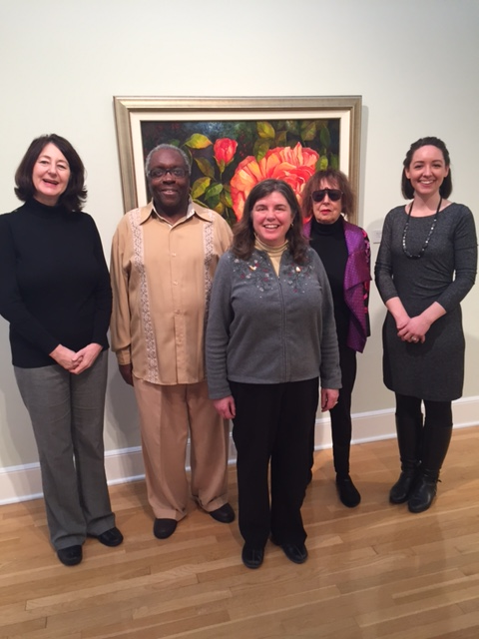
Following Gallery Curator Nicole’s introduction to the faculty art show that had opened the night before, the opening musical performers were piano duo (Pharmacy) Dr. Jennifer Hund Bucheit and (Music) Dr. Stephanie Owen (Right) who performed Gershwin’s Concerto in F, 3rd Movement for two pianos. You can enjoy their performance here. Next up was Joan Witte (Center) who performed a thrilling piano arrangement of “Great Is Thy Faithfulness” by Mark Hayes, followed by the ever-cheerful “Linus and Lucy”. Gill Cerbin (Left) offered two of Poulenc’s “Three Novelettes” performed with delicacy, virtuosity, and power. The program was polished off by Marshall Gurley’s rich baritone rendition of “Eternal Life” based on the prayer of St. Frances of Assisi that begins, “Lord Make me an instrument of thy peace. . .”. (It was particularly appropriate and moving that this occurred almost at the exact time that the Presidential Oath of Office was being administered in Washington DC.)
In addition to guest performer Jennifer and her husband Chris Buchheit, other guests were brought by Marshall Gurley and Karen Koch. Thank you to Heidi Shepherd for coordinating this special meeting.

STUDENT MASTER CLASS OPPORTUNITY
Here’s a wonderful opportunity for students to participate in the Monday, March 27 master class at McKendree offered by Dr. Joseph Welch. If anyone has students interested in participating, email him ASAP at jdwelch@mckendree.edu. It is a low-pressure, low-stress event giving students an opportunity to try out some of their repertoire. Students could also sit in on the master class without actually performing.

BELLEVILLE PHILHARMONIC YOUTH OPPORTUNITIES
The Belleville Philharmonic Youth Orchestra has provided information concerning some piano student opportunities. The Tuerck Concerto Competition will take place the afternoon of Saturday, March 25. Details for this year’s contest were posted online. Also, there may be an opening for an advanced youth piano student who is interested in auditioning for the orchestra and could split accompanying and playing his/her orchestral instrument. Contact +1.6182355600 info@bellevillephilharmonic.org . (Ed. Note: this news arrived a few weeks ago so the opening may have been filled in the meantime.)

TIDBITS
We are delighted to have a new GAE member, SARAH KOESTER from Red Bud IL. She is an independent teacher there, and is jumping immediately into the AIM pool, with plans for a Level 1 student this year! We look forward to meeting her in person. Welcome, Sarah!
STEPAHNIE OWEN’S voice student Olivia Gregory sang at NY University in NYC in the invitation-only second round of the scholarship competition in February 2017. She sang in German, Italian and French.
Ever-active DR. JOSEPH WELCH will be unable to attend the upcoming March GAE meeting because he will be on choir tour with Blackburn College traveling up the west side of Illinois before crossing over the Chicago to perform in high schools and churches. On March 6 he twice performed Gershwin’s Rhapsody in Blue with the McKendree Wind Ensemble at Yamaha’s “Music for All” event at O’Fallon Township High School. He writes: “It was an interesting day (the piano was assembled within ten minutes of my first performance - rather stressful!), and everyone can read the full, rather dramatic, story on my Facebook page if they're interested. We will perform Rhapsody again on Thursday, May 4 at 7:30pm in the Hettenhausen Center at McKendree if anyone would like to hear us.”
JOE WELCH also sent this information. “I don't know how many of us teach older and advanced students, but the SIYAO competition held in Edwardsville for instrumentalists (solo or small ensemble, age 20-30 years) offers cash prizes to the top three winners. Musicians can register online at siyao.us. I recently joined their governing board, and it is a great group of people who are very interested in supporting young artists.”
Lauren Cerbin, daughter of GILL CERBIN, was in the recent winter opera performances of “Carmen”. She will also be participating in the Missouri State High School Competition in April with flute. In GILL’S position as VP/Program Chair, she is already compiling ideas for next year and asks that if anyone has a program they would like to present for the coming year to contact her at gillcerbin@yahoo.com .
Sunday, March 5 saw KAREN KOCH and members of her family in New York’s legendary Carnegie Hall to hear granddaughter, violist Marissa Young, and her Kirkwood MO High School 100-member Symphonic Orchestra perform three numbers. Their orchestra was one of three high school musical groups who had won a national competition to perform at Carnegie. The other groups were a 24-member string ensemble from a music academy in Cincinnati and a charter school 50-member woodwind orchestra from Atlanta. It was an exciting and impressive evening of music by very accomplished high school musicians—and Karen’s first visit to Carnegie Hall. During the long weekend the Kochs squeezed in visits to the Museum of Modern Art, the Tenement Museum, and saw shows ALLADIN and MISS SAIGON. Marissa in black is shown at left with her twin Ellery before the Carnegie Hall performance. Standing at right rear in the photo are their brother, Griffin, and Grandpa Ed. An hour after this photo was taken, the stage was filled with these musicians from Kirkwood who performed, among other things, a Mahler Symphony movement.
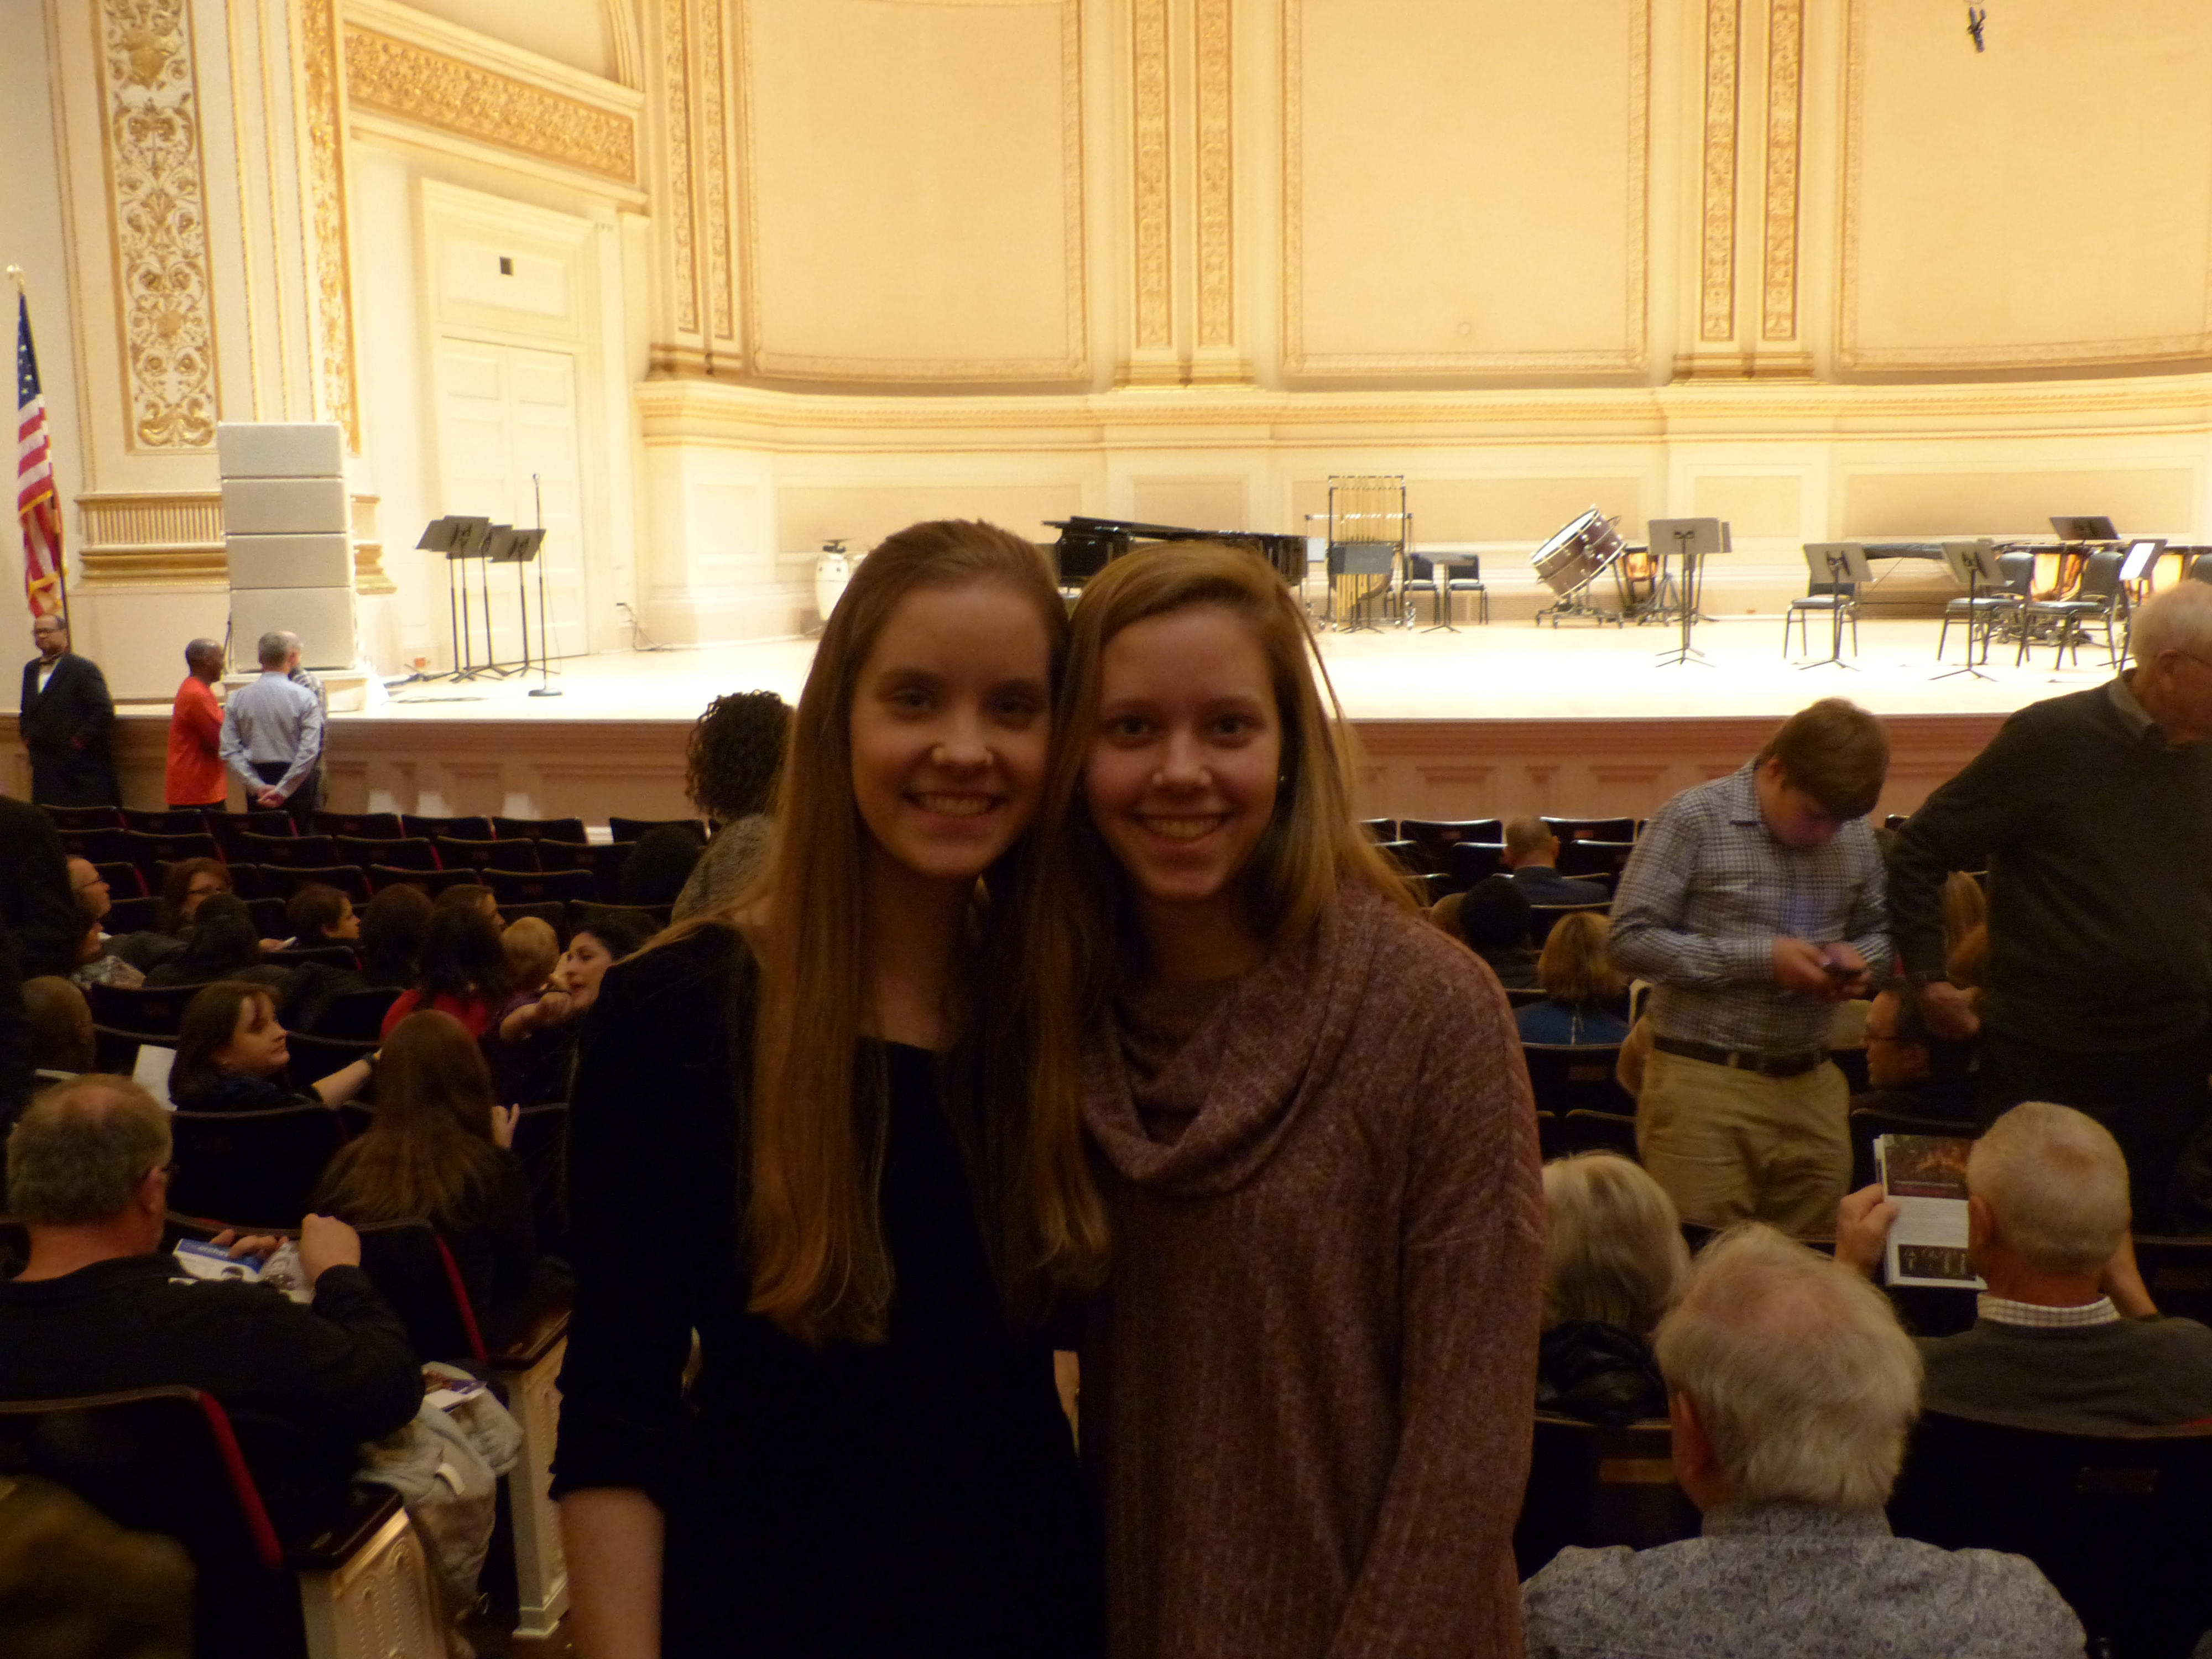
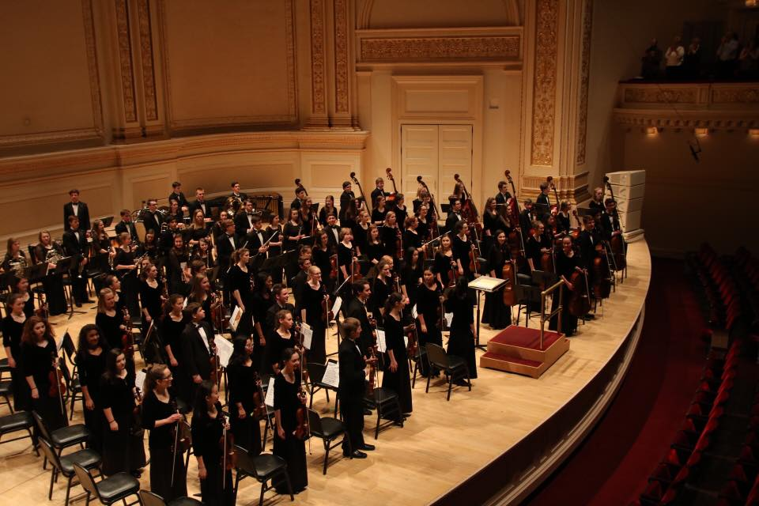

BONUS
Debbie Meier is our GAE Music Link Champion! She has been honored in consecutive issues of The LINK, the newsletter of the Music Link Foundation. This issue’s coverage is copied below:
MusicLink Fundraising Events Bring Music to the Community IL.

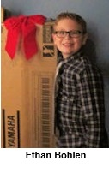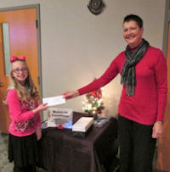
Chloe Severs presents pledge
check to Deborah Meier
A Clavinova Festival was held on December 10, 2016, in conjunction with the Third Annual Christmas Tree Walk at The Beacon, in Waterloo. The event featured performances by 34 students from five participating teachers: Grace Reuter and LeAnn Halvorson of Columbia, Sheri Jones of Waterloo, Gillian Cerbin of Belleville, and Deborah Meier of Collinsville. A big thank you to Yamaha and Piano Distributors for sponsoring and helping organize this successful event! Steven Trawford, manager of Piano Distributors, plans to continue this yearly event. We appreciate his willingness to collaborate with MusicLink through Gateway Arch East Music Teachers Association and Illinois MusicLink Coordinator, Deborah Meier. It is a fun event that keeps kids interested in piano and working hard.

Students participating in the Clavinova festival received a t-shirt, certificate, and a goodie bag containing treats, a lanyard and pen. Each student was entered into the grand prize drawing for a Yamaha digital piano (P-115). Ethan Bohlen, student of Deborah Meier was the lucky winner. He is eight years old and has been studying piano at Holy Cross Lutheran School with Mrs. Meier for about 2 years.

A total of $965 was collected from pledges to benefit MusicLink students in Illinois. Funds raised will help pay for practice instruments, music, piano moving and tunings, instrument repairs, expense reimbursement for teachers and Summer Music Camp Scholarships for students. Thank you to all the participants who raised funds through pledges for these performances and promoted MusicLink by "kids helping kids!"
END


