GATEWAY ARCH EAST CHAPTER NEWSLETTER
October 2016
http://gatewaymusicteachers.org Illinois State Music Teachers Association
President: LeAnn Halvorson; Vice President/Programs Gill Cerbin; Secretary: Tara Wright; Treasurer: Karen Koch

UPCOMING EVENTS
Fri, October 21 GAE Meeting at 10 AM, McKendree University Hettenhausen Center for the Arts. “Marketing in the Music Business”, Presenter Dr. Joseph Welch.
Sat, October 22 South District Auditions at SIUE Dunham Hall 1109,
Fri-Sun, Nov 4-6 ISMTA CONFERENCE at Illinois Wesleyan University, Bloomington. IL.
Fri, Nov. 18 GAE Meeting at 10 AM. “ISMTA Conference Feedback” presented by GAE Members who attended. Miller Music, Swansea.
Wed, Jan 18 Midnight Deadline for AIM Theory RegistrationsMa
MARKET YOUR TALENTS? LEARN HOW ON OCT 21 Dr. Joseph Welch personifies energy, excellence, and marketing know-how as an eclectic professional musician. As the organizer of a summer camp to assist student musicians with professional approaches to branding and marketing, he has many ideas about the “do’s” and “don’ts” of networking that can help professional musicians of all ages and experience. If you would like to add to your student enrollment and/or increase your professional engagement and reputation, be sure to attend the upcoming GAE meeting on October 21 for some useful ideas. ( It’s not too late to invite a non-member to the meeting. In fact, it’s a great idea!). One item on the agenda will the filling the need for a new Certification Chairman to replace Catherine Burge who is now teaching in Canada.
KINKS WORKED OUT AT SEPTEMBER GAE MEETING!
Eric Sutz, presenter for the September 16 program titled “Myofascia Release for your Arms and Shoulders”, offered helpful information and suggestions via Skype for healthy musical bodies. Reviews of his presentation have been very favorable. No reports of aching muscles so far.

YEARBOOK UPDATED AND ONLINE
Joan Witte has updated and published the 2016-17 GAE Yearbook, and it has been posted by Lauren Halvorson at the GAE website online. All current program dates, AIM information, member contact information, and past newsletters can be found on the GAE site. Any additional yearbook information should be sent to Lauren at fishmas2@gmail.com.
According to the MTNA report as of September, 2016, our GAE membership is now 29 paid members.
If you are looking to add students to your studio, you can register on the new ISMTA website tool that allows people in your area to search for local teachers. Follow the directions at the link below that not only shows you how to be added to that list but to also activate your profile on the ISMTA. website, It will allow you to store shipping information, view order status, and more. https://ismta.org/activate-public-profile

IS 2016 YOUR YEAR TO ATTEND THE ISMTA CONFERENC?
If you have never attended a state conference of ISMTA, this might be the year to consider going, as it will be held relatively nearby at Illinois Wesleyan University in Bloomington on November 4-6. The lead presenter and conference artist is Dr. Tony Caramia, but many other sessions will be presented as well. Our own Dr. Joseph Welch is doing a 50-minute conference presentation Saturday at 2 PM on “The Business of Being Pianist”, so if you can’t be at Friday’s GAE meeting, you can hear him at the Conference on Nov. 5! Other advantages of conference attendance include new teaching repertoire, inspiration, competitions, and hobnobbing with like-minded teachers from across the state. Carpools from GAE are probably available!
Conference Schedule Registration Info
Hotel Registration (Deadline Oct 20 for Conference Rate)

CLAVINOVA FESTIVAL IN METRO EAST DECEMBER 10
Yamaha/Piano Distributors is sponsoring this year’s east side Clavinova Festival on December 10 from 5:00-7:00 at The Beacon in Waterloo during their Christmas Tree Walk. Registration deadline is November 10 to LeAnnHalvorson@musicperceptions.com. Students are required by The Beacon to play Christmas music, to help set the mood for their Christmas Tree Walk. Any Christmas music is acceptable. If you have 10 or more students entering, Piano Distributors will loan you a Clavinova to use with your students in your studio for practice for this event if you don’t already own an instrument. This will facilitate the Clavinova Festival requirement that students incorporate some enhancement aspects of the digital instruments--play on a different sound, play with a midi file, use the accompaniment section of the instrument, etc.

PIANO FOR SALE
LeAnn Halvorson has received word about a Baldwin Acrosonic piano available at an estate sale in Alton. Contact Greg Stickles 847-208-4336.

TIDBITS
KATE BRAATZ is planning on an extended holiday season this year, as she is expecting her best gift on January 6 with the arrival of a baby son to complement two older sisters! .Congratulations to all!
Dr Jennifer Hund, current piano student of DR. STEPHANIE OWEN, has been hired as pianist and director for musicals at Lindenwood College in Belleville Illinois and also as pianist for Ignite Children’s Theatre in St. Louis for 2016-17. Stephanie’s voice student Caroline Cunningham was chosen to be a finalist in Belleville Junior Idol Oct 8 2016.
Thirteen of GILL CERBIN’S students recently took part in the Arch Cup piano competition at Webster University, and all gained the top ranking of “Superior Plus” with trophies.
This past weekend, Gill’s voice student Catherine Myers and daughter Lauren Cerbin were both Finalists in the Belleville Junior Idol competition.

BONUS
Karen Koch had the opportunity in September to visit the school and apartment of Franz Liszt in Budapest. His bed, prieu-dieu, rosary, table, chair and composing desk were displayed in one room, and adjoining was a large room where he conducted lessons and master classes for students with several instruments. It was awe-inspiring to stand in front of his favorite piano that was protected only by a “Please Do Not Touch” sign and a semi-watchful guard! Liszt’s composing desk had a small harmonium keyboard instead of a middle drawer.
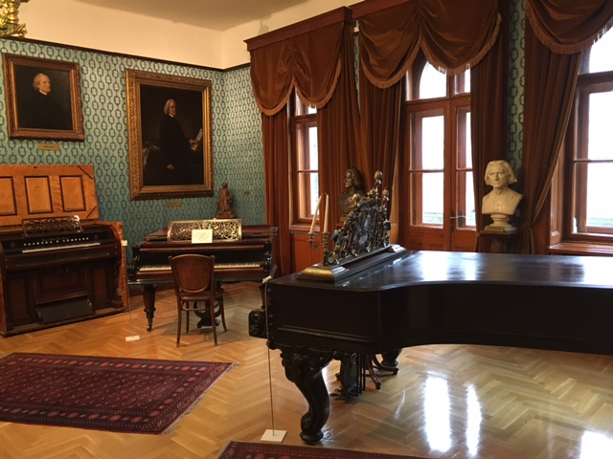
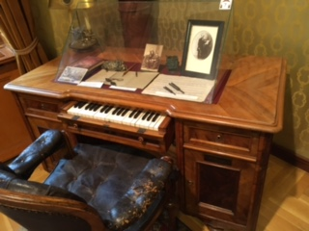

END

