GATEWAY ARCH EAST CHAPTER NEWSLETTER
January 2016
http://gatewaymusicteachers.org Illinois State Music Teachers Association
President: LeAnn Halvorson; Vice President/Programs: Mary Anderson; Secretary: Stephanie Owen; Treasurer: Karen Koch
UPCOMING EVENTS (See details below)
Wed Jan 13 Midnight Deadline for AIM Theory Registrations Level 3-12.
Fri Jan 15 AIM Repertoire Substitution requests due to hisamimyers@gmail.com
Fri Jan 15 GAE Schubertiad, Gallery Tour & Luncheon at SWIC Schmidt Art Gallery 10 AM
Sat/Sun Feb 13-14 AIM Level 3-12 Theory Exams at SWIC; TBA at SIUE

AIM THEORY EXAM ENTRY INSTRUCTIONS
The deadline for AIM Theory Exam entries, Levels 3-12, is Wednesday, January 13. Entry forms and instructions are available online at the GAE website. In addition to piano exams, voice exam requirements have been updated and this new information is available here.

SCHUBERTIAD PLANS IN PROGRESS
Most GAE programs are ABOUT making music, but the January 15 Schubertiad will be a variety of performances of anything musical by our talented members. The event also features a short guided tour of the Schmidt Art Gallery at SWIC and a salad luncheon/meeting. If you would like to perform, please notify Heidi Shepherd who is chairing the day. If you wish to attend the luncheon, there will be a $10 charge payable at lunch time, but please contact Heidi no later than Tuesday, January 12 so that she can order the appropriate amount of food. There is a minimum of 12 people needed for the luncheon. Heidi said, “This January meeting at the Schmidt has become a tradition for our group and the Schubertiad has always been oh so nice!! If any of you have music you would like to perform, please let me know.” (As of 1/9/16, there were only three performances registered to play! )

GAE WEBSITE IS REFURBISHED
GAE website editor, Lauren Halvorson, has sent word that the new website is up and running. It includes information about GAE, a “Find a Teacher” page, AIM information and entry forms, a program calendar, a member directory, archived newsletters, and other resources. IT is up-to-date and easy to use. Good Job, Lauren!

THOUGHTS OF CERTIFICATION?
Former GAE member Susan Lipnick is the current ISMTA Certification Chair, and has sent information to local certification chairs encouraging them to serve as mentors and encouraging local chapters to encourage certification perhaps by offering to pay the application fee for aspiring NCTM’s. Details on certification can be found at http://ismta.org/certification-do-you-know-that-tidbits/ or at www.mtnacertification.org.

VIRTUAL PRESENTER A REAL-TIME SUCCESS
The November GAE program at Miller Music featured Bonnie Blanchard via Skype. She is an elite flute teacher from Washington state--a clinician and author of two books on “Teaching Artistry from the Very First Lesson”. Her presentation was entertaining, enlightening, and very well received. She spoke from her studio, and shared a handout for distribution to all members in the newsletter listing points she embellished by playing her flute, using “interesting” headgear to illustrate, and generally charming the audience while sharing anecdotes and tips from the trenches of teaching.

TIDBITS
GAE members were saddened to hear of the death of DEBBIE MEIER’S mother on January 4 in North Dakota. Deb had been staying with her parents for several weeks to help with her mother’s care.
There was happier news in DEBBIE’S family as well. Her daughter, Katie Meier Schelp of Ponca City OK, is a former GAE AIM student who was named the December Teacher of the Month by the national Music Link organization. Katie’s photo and a nice article that appeared in the Music Link publicity are attached.
AMY JO SAWYER has reported that on Jan 2-3 she played the featured accordion parts in “Ratatouille” with the St. Louis Symphony and enjoyed visiting at intermission with several GAE members who were in attendance. In preparation for this performance she had to learn 79 pages of music that included 16th notes at mm.200, so in addition to home practice, she borrowed an instrument and practiced three hours every morning while in LA over Christmas.

BONUS #1
If you would love to attend a national conference but don’t have the time and money to do so, consider participating in an upcoming conference that comes to you via the internet. Sessions will be live February 2-6 and any time after on demand, and will feature a large variety of nationally known presenters. You can participate from your home during those five days of webcasts and/or view the sessions online at any time for up to a year afterward. The conference is MusicEdConnect http://www.musicedconnect.com. Here is a list of topics and presenters, Registration info is here. The originator and coordinator of this virtual conference is Michelle Sisler of Keys to Imagination, a noted tech expert who has presented tech topics throughout the US for MTNA and the National Conference on Keyboard Pedagogy to name a few. However technology is just one of many subjects that will be included at this virtual conference. You can attend while wearing your pajamas if you wish!

BONUS # 2
Twenty six students of Debbie Meier and LeAnn Halvorson received t-shirts, certificates and a goodie bag containing treats, a lanyard, pen and sunglasses along with a chance to win a Yamaha digital keyboard when they participated in the Clavinova Festival on December 12 in Waterloo. Benjamin Thomas, student of Deborah Meier was the lucky winner. He is nine years old and has been studying piano at Holy Cross Lutheran School with Mrs. Meier for about 2 years. Yamaha and Piano Distributors sponsored the event under the direction Steve Trawford. The Festival was held in conjunction with a Christmas Tree Walk in Waterloo, and included a fund raising event for MusicLink which raised over $900 from pledges to benefit deserving Illinois music students.

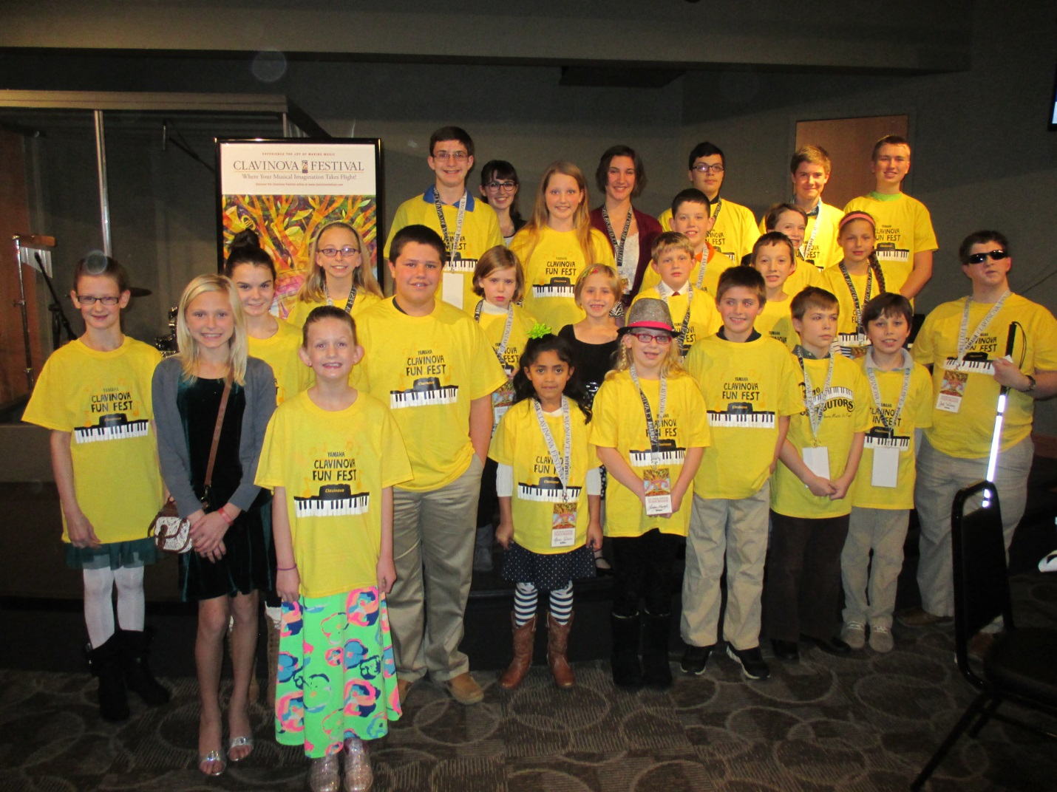
The Clavinova Festival is planned as an annual event open to all students who perform using some of the various instrumental sounds, drum rhythms, and/or accompaniment styles available on a Clavinova keyboard.

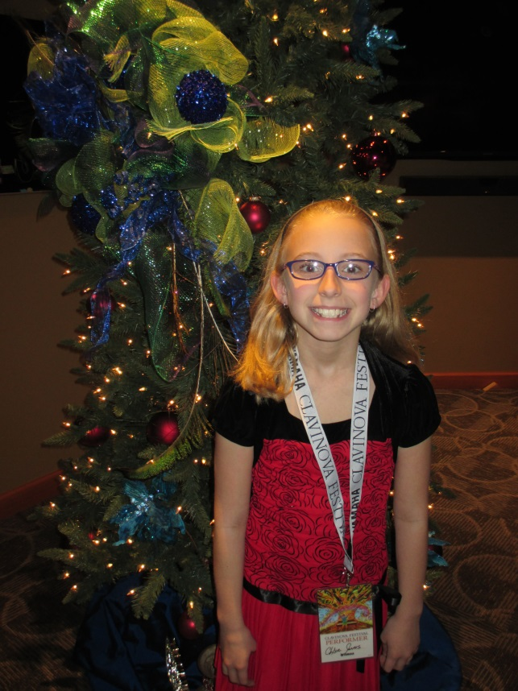
Chloe Severs, (left) Clavinova Festival Participant, donated $270 to MusicLink Foundation. to help pay for practice instruments, music, piano moving and tunings, instrument repairs, expense reimbursement for teachers and Summer Music Camp Scholarships for students. Chloe attends Holy Cross Lutheran School, Collinsville, and is in the 3rd grade.
Benjamin Thomas won the Yamaha keyboard at the Festival. He is nine years old and has been studying piano at Holy Cross Lutheran School with Mrs. Meier for about 2 years.
