GATEWAY ARCH EAST CHAPTER NEWSLETTER
November 2016
http://gatewaymusicteachers.org Illinois State Music Teachers Association
President: LeAnn Halvorson; Vice President/Programs Gill Cerbin; Secretary: Tara Wright; Treasurer: Karen Koch

UPCOMING EVENTS
Fri, Nov. 18 GAE Meeting at 10 AM. “ISMTA Conference Feedback” presented by GAE Members who attended. Miller Music, Swansea.
Wed, Jan 18 Midnight Deadline for AIM Theory Registrations

COULDN’T ATTEND THE 2016 ISMTA CONFERENCE?
Reprise Upcoming
Here’s your second-best option: attend the upcoming Nov 18 GAE meeting, where the program will consist of those members who were there sharing the best information that they acquired. GAE was well represented by our Member of the Year Joan Witte, along with LeAnn Halvorson, Debbie Meier, Amy Jo Sawyer, Gill Cerbin and Karen Koch. Le Ann and Karen had exhibits, and everyone participated in sessions on a variety of topics.
Our own Dr. Joseph Welch had a highly-acclaimed ISMTA Conference presentation on “How to
Prepare Students for the Modern and Future Field”. One quote from the departing audience, “I’ve been attending these things for 20 years and this was the best one ever!” High praise indeed!

IN OCTOBER, GAE LEARNED MARKETING FROM JOE!
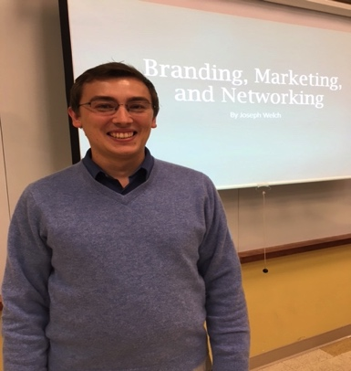
At the October 21 GAE meeting Dr. Joseph Welch offered a Conference “warm-up” with his thought-provoking and interesting session for teachers who wish to leverage their individual skills and experiences so that their public image is accurate and effective. His topics included creation of printed business documents, use of social media, community networking, choice of colors and photos to express personality, and audience participation for applying the ideas. Every attendee departed with new ideas to be put into practice for their own brand of piano teaching.

YEARBOOK UPDATES & CORRECTED EMAIL FOR LAUREN
All current program dates, AIM information, member contact information, and past newsletters can be found on the GAE site. Also, there is a Find a Teacher page on our GAE website. If you would like to be listed there and have not already submitted a request, send the information you would like to have listed to Lauren Halvorson, who is updating the page.
A mea culpa from your newsletter editor who, for two months in a row, provided an email for Lauren that included a typo. The one shown here is correct, so if you tried to send her information that bounced back, that is why. Any additional yearbook information should be sent to Lauren at fishmas1@gmail.com.

MEMBER BENEFITS FROM YOUR MTA MEMBERSHIP
Are you taking advantage of the member benefits that are yours? For example the MTNA Members-Only site has information about past webinars that are still viewable, special discounts for office supplies, insurance, and car rentals, and studio resources.
There is a Find a Teacher option also at the ISMTA website. Go to ismta.org and click on the Find a Teacher link for instructions to be included.

CLAVINOVA FESTIVAL IN METRO EAST DECEMBER 10
It’s too late to enter, but if you are considering this for the future, you might want to attend this year’s east side Clavinova Festival on December 10 from 5:00-7:00 at The Beacon in Waterloo during their Christmas Tree Walk. Students play Christmas music to help set the mood for their Christmas Tree Walk. Any Christmas music is acceptable.

ANOTHER PIANO FOR SALE
Marilyn Boyd has personally inspected this 30-40-year-old Wurlitzer spinet in perfect condition being offered by a friend . Marilyn says it looks and sounds great, as it has been regularly tuned. Asking price is just $290! Contact her if interested. 618-363-2212.

MUSIC LINK MESSAGE from Debbie Meier
I wouldn’t doubt that [some of you] are already reducing fees for students who are in danger of dropping out of lessons because of financial need and I’m reaching out to you to see if we can help. Teachers can easily become a MusicLink teacher and encourage a student to register as a ML student. We can offer discounted and free music for the students, and discounts on teaching aids for the teachers. We reimburse teachers up to $100/year for any expenses they might incur helping the students (e.g. purchasing a metronome, helping pay registration fees for festivals, Guild, etc., special music, and even repairs on an instrument). Tuition is not covered but there are many other offers. Contact Deb for details

TIDBITS – (see photo gallery below)
As a student of Dr. Jolly at SLU in Missouri, Lauren, daughter of GILL CERBIN, is a vocal finalist in the UMSL Concerto Competition to be held at the Touhill on the UMSL Campus.
This month’s report form STEPHANIE OWEN celebrates vocal student Olivia Gregory who passed the first cut and was invited to fly to New York University to sing opera in February. She will sing “”Vissi d’arte from Tosca. She also received a mentorship with The Bach Society in St Louis for 2017. Voice student Chloe Schobert won an assisting role in Little Mermaid at Belleville West.
AMY JO SAWYER’S composition student Walter Thomas-Patterson has won another national award—3rd place bronze medal in the annual Hal Leonard Publishing Company Composition Contest Teen Division with 60 contestants. He will be performing his winning piece, Furtive Chase” at Amy’s student recital Saturday, November 19 at LDS Church Chapel, 255 Fairwood Hills Dr. in O’Fallon. Public is invited and this includes GAE members.

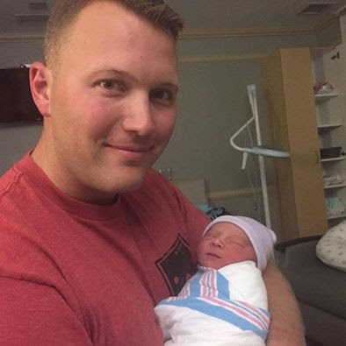DEBBIE MEIER is traveling to FL to meet her first grandchild, Thomas James born to her son Nick and his wife on Nov 7. Nick is an active duty Marine stationed there. Debbie isI on a “grand” roll, as daughter Katie will deliver grandchild #2 in Oklahoma in May! Both Nick and Katie are former AIM participants. Congratulations to all!

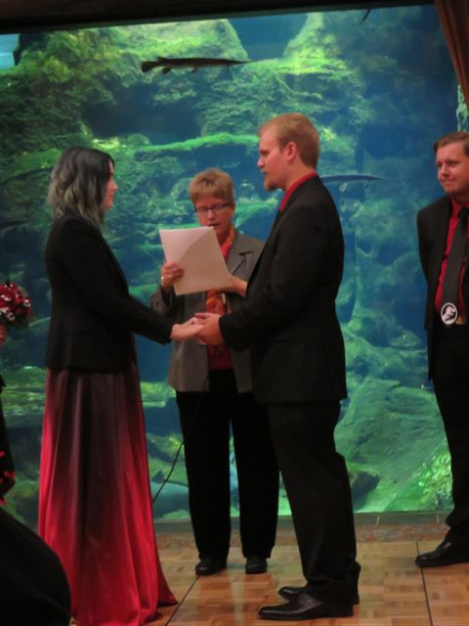
JOAN WITTE and GAE tablemates after receiving her Member of the Year Award at Illinois Wesleyan University ISMTA Banquet on Nov 4. (Photo by another tablemate, Keith Sawyer.) 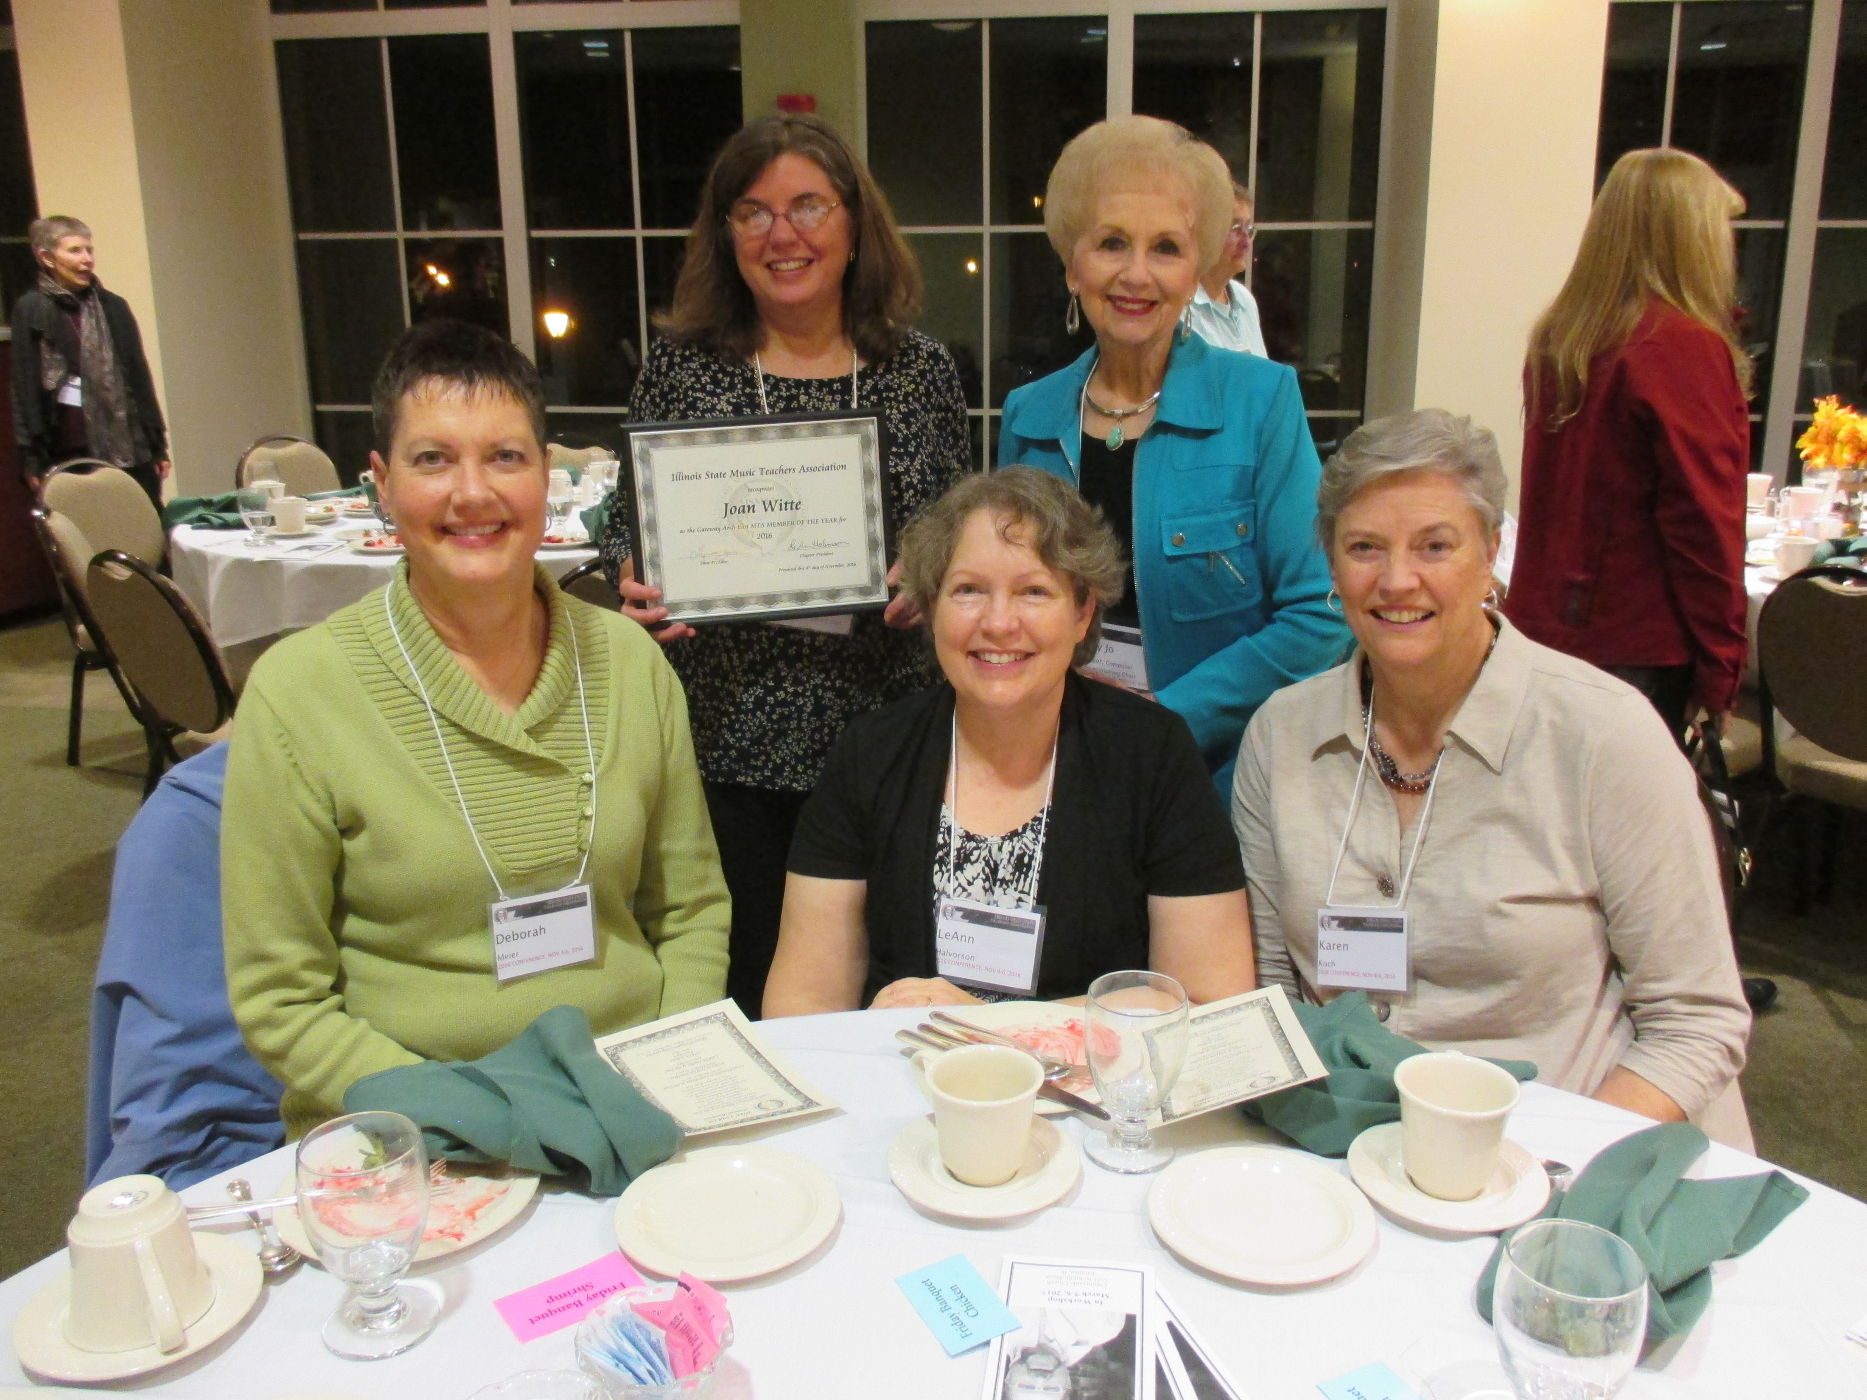

LEANN HALVORSON was the mother of the bride when daughter Lauren married Josh Buechler on October 1 at the St. Louis Zoo. The theme of the wedding was Jurassic Park for the quote “Life finds a way”. Lauren is keeping her Halvorson name so that she can be found in her work as a freelance artist (and as our GAE Webmaster!)

