GATEWAY ARCH EAST CHAPTER NEWSLETTER
December 2014
http://gatewaymusicteachers.org Illinois State Music Teachers Association
President: LeAnn Halvorson; Vice President/Programs: Mary Anderson; Secretary: Stephanie Owen; Treasurer: Karen Koch
Please send newsletter information to: Karen Koch, 618-224-7102, kk@musicedmarket.com

UPCOMING EVENTS (See details in articles)
Wed, Jan 14* AIM Entry Forms Due by midnight:
1) AIM Student Enrollment Fee & Form to Karen Koch (US Mail)
2) AIM Teacher Judging Form to Heidi Shepherd (Email or US Mail)
3) AIM Student Enrollment Forms
SWIC Exams to LeAnn Halvorson (Email or US Mail)
SIUE Exams to Dr. Huei Li Chin (Email or US Mail)
Thur, Jan 15 AIM Repertoire Change Requests Due to Stephanie Myers
Mon, Jan 19 Reservation Deadline for Schubertiad luncheon & performers.
Fri, Jan 23 GAE Schubertiad: Art Gallery Tour, Teacher Performances, and Luncheon. SWIC Schmidt Art Center. Contact Mary Anderson or Heidi Shephard for details or registration. FREE LUNCH!
Fri-Sat, Feb 14-15 AIM Theory Exams, Levels 3-12.

*There was some confusion regarding the AIM deadline dates, as some of the entry forms online still showed last year’s dates. However the entry deadline is one month before the exams are to be held, so midnight January 14 is the correct date for the 2015 deadlines. The forms now are correct.
AIM PLANS ARE IN HIGH GEAR
This year’s edition of Achievement in Music is upon us. Three different theory entry forms are to be sent to three different people, as mentioned in the calendar above. Addresses and email addresses are in the GAE Yearbook and online. For the April performance exams, Levels 1-12, repertoire pieces can be used – this year only—from either the old or the new syllabus. Any pieces other than those listed in either syllabus version must be approved in advance by contacting Stephanie Myers ( hisamimyers@gmail.com ) of ISMTA by January 15. Other questions can be answered by state contact persons i.e. questions on new Theory Exams: Rita Brown, AIM Theory Chair, 630-668-0649. Questions on Technique or Repertoire or Level 12 Repertoire Permission: Debbie Gillette, AIM Repertoire Chair ( pianodeb@msn.com )

SCHUBERTIAD PERFORMANCES JANUARY 23
Mary Anderson and Heidi Shepherd are heading the arrangements for the January 23 Schubertiad at Schmidt Art Center. GAE will cover the lunch cost for members, but reservations for performers or lunch need to be called (618-233-4584) or emailed (h.shep8@gmail.com ) to one of them no later than Monday, January 19. As in the past, we will enjoy a brief tour of the three museum exhibits following the Schubertiad performances presented by GAE members. All performers are welcome.

WOMEN ARTISTS AND COMPOSERS CELEBRATED
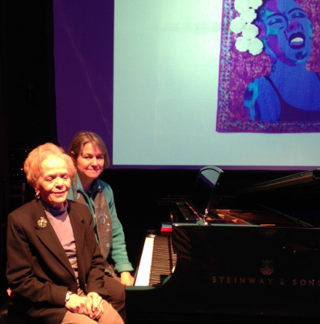
Barbara Kramer and Ann Davidson Celebrating Women Artists November 21

The November 21 GAE meeting at Lewis and Clark was a special treat. Barbara Kramer performed pieces by women composers Clara Schumann, Cecile Chaminade, Marian McPartland, and Carol King. Ann Davidson interspersed the music with Power Point photos and stories of Lewis and Clark’s campus art work by women. Hatheway Cultural Center itself is a beautiful architectural venue. Following the meeting most of the attendees extended the morning with lunch together at nearby Josephine’s Tea Room. Holiday décor and desserts were the stars there.
Business at the meeting included: (See related story below)

- Decision to offer $50 to future Members of the Year to cover their expenses in attending the ISMTA Banquet Awards Dinner.
- Discussion and subsequent vote to offer up to $300 to co-sponsor with St. Louis teacher groups a possible presentation next September 11 by Dr. Fred Karpoff. His presentation would deal with using his whole-body, injury-preventive approach to piano playing and teaching, used in over thirty countries around the world for beginning piano students through professional careers.

GAE ONLINE VOTE RESULTS
Both Barbara Kramer and Ann Davidson donated back their payment for the November program presentation. Barbara requested that her $50 be used to support the possible Karpoff presentation in conjunction with the St. Louis area piano teacher organizations, so President LeAnn requested an online vote to increase the maximum offer to $350 from the original maximum offer of $300. The resulting vote tally was 10-1 in favor. In the online voting Heidi Shepherd suggested that Ann Davidson’s $50 be donated to the Lewis and Clark Art Department in her name, and this suggestion also passed.
MTNA IN LAS VEGAS
The annual conference of the Music Teachers National Association (March 21-25, 2015) will happen this year in Las Vegas at the Rio Hotel. Highlights of the Conference will include evening recitals by Lady Jeanne Galway and Sir James Galway, the Canadian Brass, and Ann
Schein. Lang Lang will present an advanced piano master class, and Scott McBride Smith will conduct an intermediate piano master class. Conference attendees have the opportunity to network with colleagues from around the globe, experience sessions by internationally known pedagogues and witness performances by accomplished artists and budding student competitors. Schedules and registration information are available at www.mtna.org .

MUSIC LINK NEWS (from Debbie Meier)
Our goal of 6,000 students by the end of 2014 has been reached! How remarkable! If any teachers are currently teaching students on a scholarship but you are not a MusicLink teacher, please contact Deb to find out how easy it is to become a MusicLink teacher. There are many benefits to becoming a MusicLink teacher and you will have the satisfaction of helping someone in need by providing piano lessons.

SCOTT JOPLIN PIANO COMPETITION
The Fifteenth Annual Metro South Scott Joplin Piano Competition will be held on Saturday, February 7, 2015 beginning at 9 AM at Peace United Church of Christ in Webster Groves, MO. Three age divisions will compete for $50, $75, or $100 prizes: Ages 7-10, Ages 11-14, Ages 15-18. Entry Deadline is Friday, January 9. Entry fee $10 to Metro South Scott Joplin Piano Competition, 4900 South Lindbergh, St. Louis MO 63126-3299. Information: Dr. Frances Irwin (314-752-2585 or fmirwinstl@aol.com )

KEYBOARDIST JOB OPENING (from Marilyn Boyd)
Lebanon First United Methodist Church, Lebanon IL is in need of a Christian musician to serve as the Sunday morning keyboardist for approximately ten hours a week including choir practice, Roland keyboard, possible Renner Pipe Organ playing and choir director fill-in. Job description is attached. Contact Reverend Peter Wehrly, Pastor, Lebanon First UMC (618/537-6622 or peterwehrly@gmail.com ) or Jack Rogers, Chair Lebanon First UMC SPRC (618/803-9041 or jrogers@tapestrysolutions.com).
TIDBITS
HEIDI SHEPHERD will have welcomed five new grandchildren within a one-year span by next summer. The total will then be 14 and she is thinking of hiring a secretary to recall all those special birthdays!
Voice students of DR. STEPHANIE OWEN have been busy successfully auditioning. Lauren Cerbin won first in the Alton Philharmonic Marie Stillwell Concerto in the 12 and under division on November 22. She earned the right to solo with the symphony. Lauren also sang “Ave Maria” at the St. Theresa School Christmas Eve Mass. Voice student Shannon Nettemeyer will play the part of Jane in “Tarzan”, Mater Dei High School’s Spring Musical, and also survived the first round of a $2000 college scholarship competition at the Hidden Lake Winery and will compete in the second round on January 10. Caroline Cunningham won the opportunity to sing “O Holy night” in a performance of “Christmas Carol at Althoff High School and then at midnight mass at St Cyprian Catholic church in Downers Grove IL on Christmas Eve and again at a memorial service at the same church on Dec. 26.
JAN ROCK shared some video of her fall semester recital. She particularly recommends a ragtime piece, “Sedalia Stomp” by Galen Wilkes, arranged by Jack Bradshaw. Her student in this video is Casey Corkery and together they offer a rousing performance!
DR. JOSEPH WELCH of McKendree University spent a twelve-day residency with the Heartland Symphony Orchestra in October in Little Falls MN. While there he did 29 outreach presentations in schools for the Orchestra. Dr. Welch spoke to over 1500 students of all ages, explaining the background o Rachmaninoff’s Second Piano concerto and demonstrating excerpts of it. The presentations were well received and many students attended one of the three concerts.
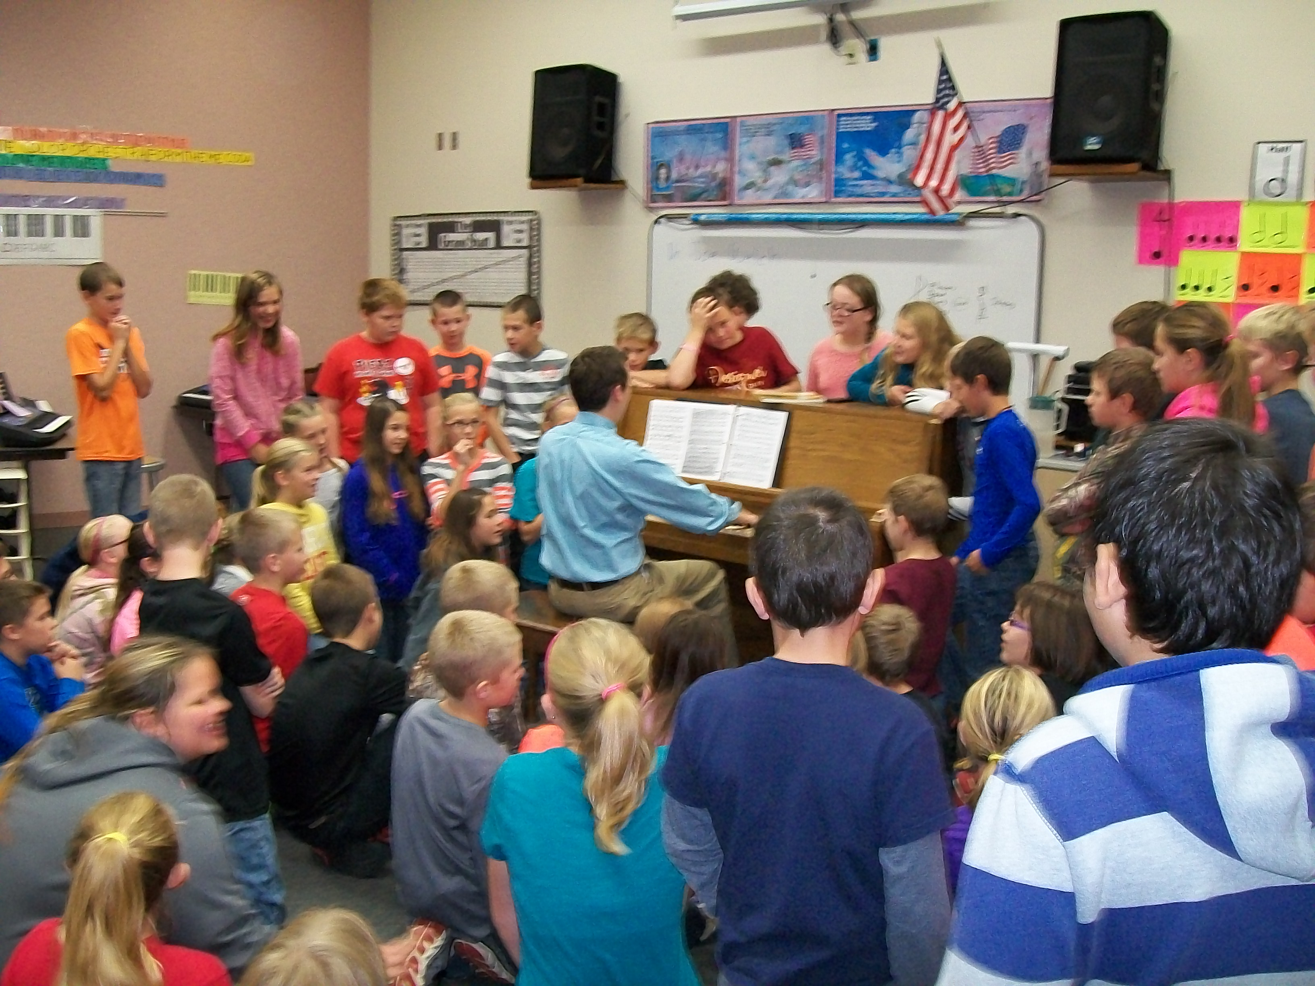
Joe Welch with Minnesota students (above) and in concert (below).

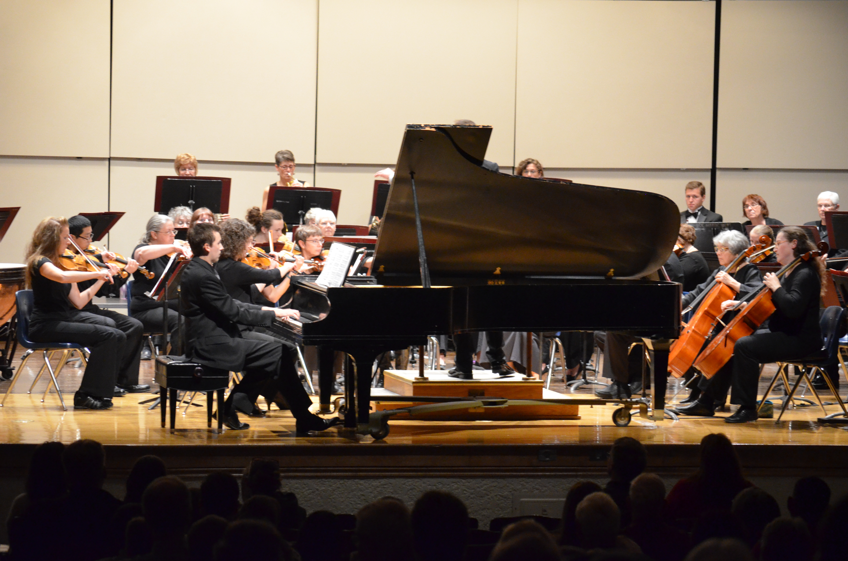

Bonus
Looking to increase your student load? Have you heard of Thumbtack? Here are the details:
http://88pianokeys.me/2014/11/14/need-to-pin-down-new-students-try-thumbtack

