Please send newsletter information to: Karen Koch, 618-224-7102, kk@musicedmarket.com GATEWAY ARCH EAST CHAPTER NEWSLETTER
February 2015
http://gatewaymusicteachers.org Illinois State Music Teachers Association
President: LeAnn Halvorson; Vice President/Programs: Mary Anderson; Secretary: Stephanie Owen; Treasurer: Karen Koch

UPCOMING EVENTS (See details in articles)
Fri, Feb 20 GAE Meeting 10 AM at McKendree University Hettenhauser Center for Arts. Dr. Joseph Welch, Clinician
Wed, Mar 4 Midnight AIM Repertoire Forms Due.
Wed, Mar 11 Midnight AIM Levels 1-12 Student Registration Forms Due: Fee Form, Judging Form and Student Enrollment Form
Sat-Wed, Mar 21-25 MTNA National Conference at Las Vegas Rio All-Suites Hotel
Fri, Mar 27 GAE Meeting 10 AM at Piano Distributors. Program: “Duet Variations” by Dr. Stephanie Owen and Gill Cerbin
Sat/Sun Apr 11-2, 18-19 AIM Performance Exams, All Levels

GAE MEETING FEB 20 AT McKENDREE UNIVERSITY
Dr. Joseph Welch will present “Introducing Collaborative Pieces for Early Advanced Pianists” at the next GAE meeting on Friday, February 20 in the Hettenhausen Center on the McKendree University Campus at 10 AM. He will share his perspective on the need for, benefits and challenges of teaching ensemble skills. A high school student will demonstrate specific selections to illustrate his presentation.
Dr. Welch is the Instructor of Piano and Vocal Accompanist at McKendree University. At SIUE, he accompanies vocal and instrumental students, music directs the children's opera, and recently filled Marc Schapman's sabbatical (fall 2014). Other opera credits include working with Marble City Opera (Knoxville, TN) and four seasons of coaching and conducting at Midwest Institute of Opera (Bloomington, IL). Recent concerto performances include Gershwin's Rhapsody in Blue and Rachmaninoff's Second Piano Concerto. Dr. Welch graduated from SIUE ('09) with a BM in Piano Performance and the University of Minnesota with degrees in Collaborative Piano and Vocal Coaching (MM '11; DMA '13). His applied teachers include Linda Perry, Noriko Kawai, and Timothy Lovelace.

AIM PERFORMANCE EXAM ENROLLMENT INFORMATION (from Joan Witte) ED. NOTE: Please read carefully!

This year’s AIM performance exams for all levels are scheduled for the weekends of April 11-12 and 18-19. All entry forms can be downloaded from the GAE website. For all teachers, send ENROLLMENT FEE forms and checks made out to Gateway Arch East Chapter to Karen Koch, 442 N. Maple St., Trenton, IL 62293. Deadline is midnight, March 11. Fees are $15 per student for Levels 1A, B, C and 2 only. Higher level students’ fees have already been paid with their theory registrations.
All SIUE Prep students will do their testing as set up by the Keyboard Development Program. Participants at SIUE, send STUDENT ENROLLMENT and REPERTOIRE forms to Huei Li Chin, hchin@siue.edu.
Teachers whose students are testing at SWIC, send REPERTOIRE FORMS via email to Kate Braatz at musikate@gmail.com OR via Postal Service to Mary Anderson, 342 N. 43rd St., Belleville, IL 62226. Deadline is midnight March 4. Send TEACHER JUDGING and STUDENT ENROLLMENT forms to Joan Witte, 298 W. Oak St., Aviston, IL 62216; joan.witte@sbcglobal.net. Deadline is midnight March 11. Please note the STUDENT ENROLLMENT form is set up differently this year. Instead of listing the dates a student is not available, please list ALL possible dates the student is available to take the exam. Also note AM or PM restrictions, if necessary. If at all possible, please refrain from requesting a specific time for the exam, as this makes scheduling very difficult.
As a reminder, all teachers enrolling students at the SWIC testing site are required to judge or monitor at least a half day, regardless of the number of students entered. The required judging time is one half day for every 8 students entered; e.g. 1-8 students = ½ day, 9-16 students = 1 full day, etc.
Any students requesting a schedule change after the enrollment deadline will be assessed at $10 rescheduling fee. Teachers should collect all rescheduling fees from students, then mail a check for the total amount to the scheduler, Joan Witte. If a student will be taking a make-up exam after the regular testing dates, then the fee is paid to the judge. As noted above, teachers should collect the fee from the student and send it to the person judging the exam. THE DEADLINE FOR ALL RESCHEDULING REQUESTS IS THE WEDNESDAY BEFORE THE TESTING DATE FOR WHICH THE STUDENT IS ALREADY SCHEDULED OR WISHES TO BE RESCHEDULED, WHICHEVER COMES FIRST.
For further information on AIM exams, please see the GAE 2014-15 Yearbook and the Preface to the 2014 AIM Syllabus.
Questions on Technique or Repertoire or Level 12 Repertoire Permission: Debbie Gillette, AIM Repertoire Chair ( pianodeb@msn.com )

AIM THEORY EXAMS IN THE REAR VIEW MIRROR
This year’s edition of Achievement in Music Theory Exams for Levels 3-12 took place February 14-15. SWIC Theory Scheduler this year is LeAnn Halvorson, and Dr. Huei Li Chin schedules at SIUE. Enrollments have been received from 8 students/4 teachers at SIUE and 57 students from 11 teachers at SWIC. This included three Level 12 students this year. Other levels were 17 for Level 3, 10 for Level 4, 10 for Level 5, 8 for Level 6, 5 for Level 7, 3 for Level 8, 4 for Level 9, 3 for Level 10, 1 for Level 11.
In a related bit of news to apply for next year, Christine Hermanson’s online Music Learning Community has announced that they have updated their games to reflect updates for the AIM Syllabus. They have restructured Levels 1A through 7 to reflect the changes, and have added written a aural theory test learning games for Levels 8 and 9. Teachers subscribe to this service, and their students can log on from home with their own username and password. Additional information is available at http://www.musiclearningcommunity.com .

SCHUBERTIAD SPARKLED
This anticipated event for GAE was worth the wait. A wide variety of performances and a gallery tour preceded the GAE-sponsored salad luncheon. Performers pictured below were:
Joan Witte, piano (“Meditation on Hymn tune ‘Candler’” arr. Vicki Collinsworth and “Sing to the Lord” arr. Mark Hayes)
Marshall Gurley, bass. “Send in the Clowns” by Stephen Sondheim. Accomp. Amy Jo Sawyer.
Gill Cerbin and Stephanie Owen, piano duo. “Andante and Variations” Op. 83A, Felix Mendelssohn
Catherine Burge and Marilyn Boyd, piano duo. “Dolly” from ‘Berceuse Suite Op. 56, Faure
Amy Jo Sawyer, accordion. “Sonata in A Minor” Domenico Scarlatti and “Juntos (Together)” by Amy Jo Sawyer.
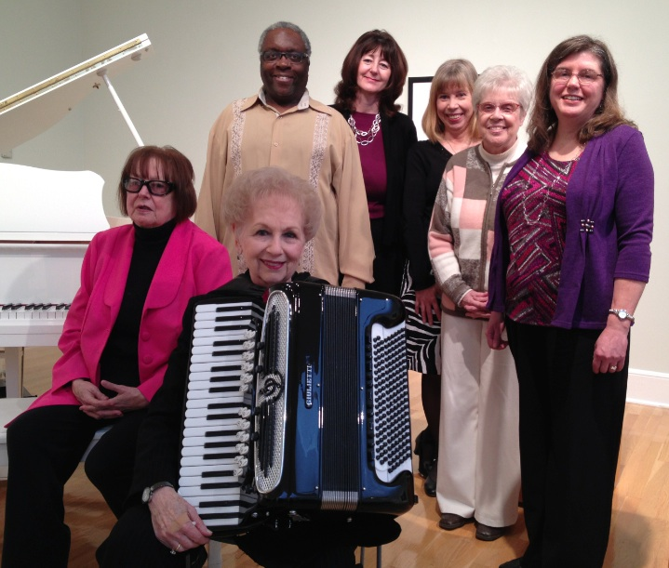
WEBSITE EDITOR DONNA GUILLAUME NEEDS RELIEF
Donna has announced that she and her husband are moving in February to Tennessee to be nearer their children and grandchildren. As a past GAE president, AIM judge/supporter, and GAE website editor since the site was created, she leaves a big footprint in GAE history. President LeAnn Halvorson has appealed for a volunteer to take over the website updating, and Donna has offered to do any training necessary. The job does not require a big time commitment, and shapes the face of GAE online for members and other visitors alike.

MTNA IN LAS VEGAS
The annual conference of the Music Teachers National Association (March 21-25, 2015) will happen this year in Las Vegas at the Rio Hotel. Highlights of the Conference will include evening recitals by Lady Jeanne Galway and Sir James Galway, the Canadian Brass, and Ann
Schein. Lang Lang will present an advanced piano master class, and Scott McBride Smith will conduct an intermediate piano master class. Schedules and registration information are available at www.mtna.org . At least two GAE members plan to be in attendance—Karen Koch as an exhibitor and Catherine Burge.

MTNA INTRODUCES 6-MONTH MEMBERSHIP
In order to provide encouragement for hesitant potential members, MTNA has announced a new half-price 6-month membership option.

MUSIC LINK NEWS (from Debbie Meier)
The recent Clavinova Festival at Piano Distributors received lots of press in the latest Music Link Newsletter. The picture and article below both appeared in their newsletter.
The holiday season is a perfect time for students to come together to perform for others, with teachers and organizations pairing these occasions with a way to help other kids get music lessons through MusicLink. You may get ideas of your own from these successful and enjoyable events:
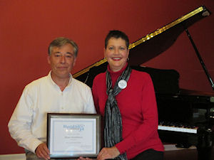
IL: A Clavinova Festival was held at Piano Distributors in Fairview Heights IL, featuring performances by 27 students from 4 participating teachers (LeAnn Halvorson, Katie Hanley, Pam Masching, and Deborah Meier). Our thanks to Yamaha and manager Steven Trawford for organizing this annual event, cooperating with Gateway Arch East MTA and Illinois MusicLink Coordinator, Deborah Meier. Every student received a T shirt, certificate and goody bag. Mitch Baldwin, a student of LeAnn Halvorson, won the grand prize of a Yamaha digital keyboard. The event raised $500 for the MusicLink Foundation.
SIUE YOUNG PIANISTS COMPETITION (from Dr. Huei Li Chin)
We're excited to announce the SIUE Young Pianists Competition scheduled for April 18, 2015! You may enter students in three divisions, categorized by their ages as of January 1, 2015. Each contestant will perform piano pieces of two contrasting styles and era. Judges will select three winners from each division. Cash prizes are awarded to each winner!
Attached are a poster and competition information. The application deadline is April 4, 2014. For more information, click here.

KEYBOARDIST JOB OPENING (from Marilyn Boyd)
Lebanon First United Methodist Church, Lebanon IL is in need of a Christian musician to serve as the Sunday morning keyboardist for approximately ten hours a week including choir practice, Roland keyboard, possible Renner Pipe Organ playing and choir director fill-in. Job description is attached. Contact Reverend Peter Wehrly, Pastor, Lebanon First UMC (618/537-6622 or peterwehrly@gmail.com ) or Jack Rogers, Chair Lebanon First UMC SPRC (618/803-9041 or jrogers@tapestrysolutions.com).
TIDBITS

AMY JO SAWYER experienced a performance first in a lifetime of performances. During the Schubertiad, she somehow cut her finger on her accordion while playing, and when she noticed blood trickling down, she paused to protect her instrument. Mary Anderson produced a band-aid, and Amy’s performance resumed with a lovely self-composed tango.
Moving preparations have not gone as smoothly for the Guillaumes as they might have wished. While helping DONNA GUILLAUME with sorting and packing, her daughter-in-law was working in the attic when the floor gave way and she plummeted to the floor below. She was “fortunate” to escape with two broken ankles and a broken foot, rather than head injuries, but surgery was necessary to repair one ankle and foot. With four small children at home, having grandparents who have moved nearby will be a huge asset for the young family as she recovers.
Two students of GAE teachers were finalists and won top prizes at the January Black Tie & Talent Scholarship Competition held at Hidden Lake Winery. Shannon Netemeyer, student of DR. STEPHANIE OWEN spoke about heroes and sang “Heroes” by Maria Carey to earn 2nd place and an $1800 scholarship. Madeline Moylan (Level 9 AIM in 2014), former student of KAREN KOCH and a current freshman a Millikin University, spoke about music in our lives and performed the first movement of Mozart’s “Fantasy in D Minor” K. 397. She was awarded third place and a $1500 scholarship.
DR. JOSEPH WELCH gave a master class and presentation on January 24 for the Illinois State University's MTNA group. Undergraduate and graduate level students participated and played solo and collaborative repertoire. Dr. Welch's presentation about the changing face of piano careers lead to a discussion about preparing for the field.
The 1st and 2nd place winners at the St. Louis Ragtime Competition were both students of AMY JO SAWYER. Congratulations to them and to her.
Students Christine Fink (GILL CERBIN) and Lauren Cerbin (DR. STEPHANIE OWEN) will be participating in Dr Welch's masterclass on March 3rd at McKendree University.



