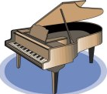
GATEWAY ARCH EAST CHAPTER NEWSLETTER

August 2017
http://gatewaymusicteachers.org
UPCOMING EVENTS

Fri, August 18 GAE Pot Luck Luncheon, Apps & Chats at Miller Music, Swansea, 10:00-1:00.
Fri, September 15 GAE Meeting, McKendree University. “Interpreting the Composer’s Intent” by Dr. Jeffrey Duce of Illinois State University. 10 AM-Noon.
Fri, October 20 GAE Meeting at Gill Cerbin’s Home. “Introducing Impressionism to Students” by Dr. Daniel Schene of Webster University. 10 am-Noon
Nov 3-5 ISMTA Annual Conference at Olivet Nazarene University in Bourbonnais IL.

READY TO ROLL INTO 2017-18?
Challenged by scheduling? Confused by the huge number of apps available for teaching? Hungry for some professional interaction (and lunch)? Solutions await on Friday, August 18 at Miller Music when President LeAnn will gavel the 2017-18 year to order at Miller Music. The year’s programs will be revealed, the budget passed, and perhaps there will be an opportunity to get acquainted with some new members who have joined. Bring lunch food to share and a friend! Budget Attached!

SWIC DAY OF PLAY JULY 15
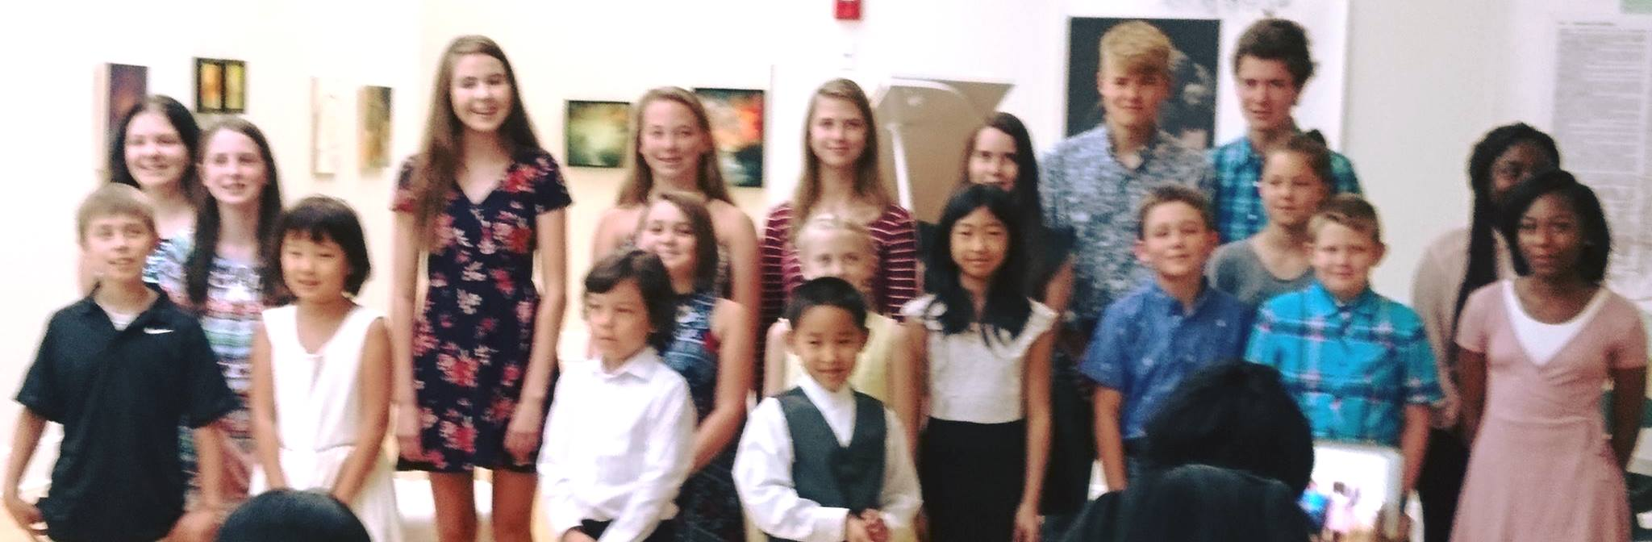
It must have been a busy day at Schmidt Art Gallery where these students presented a musical afternoon at the annual event. Participating teachers were Mary Anderson, Gill Cerbin, Marshall Gurley, Jennifer Anderson and LeAnn Halvorson. Parents helped move chairs and the piano into the open area, as SWIC funding wasn’t there to open on Saturday and Sundays, but it all worked out!
ISMTA STATE ACTIONS

- Beginning in 2017 as a pilot program there will be just two districts in the state competitions—north and south—each with its own competition and separate winners.
- The Composer Commissioning Program specifies that the “established composer” be at least 22 years of age.
- State dues for 2018 will be raised from $32 to $35.
- AIM student fees paid by local associations will be raised to @$3 for Levels 1-8 and @$5 for Levels 9-12. Plaques that are awarded to Level 9-12 students will cost $12 each.

TIDBITS
DR. JOE WELCH received a surprise when he received last month’s newsletter. In it he learned that at the May meeting he had been voted as the GAE Member of the Year! In this case, no news was good news!
Nationally Certified Teacher of Music (NCTM) is a designation offered by MTNA following a rigorous program of education and practice. Last month 7 GAE members were named as having completed this certification, but we missed BARBARA KRAMER who is also a NCTM In that list. Sorry, Barbara!
LOUANNE MURPHY, Director of the Highland Community Chorus, is inviting singers to audition for the chorus. Information is here.
DEBBIE MEIER has sent a reminder that group subscriptions to Clavier Companion magazine are available to be delivered to your home address. To get $10 off a regular subscription contact Debbie to subscribe or renew your current subscription. This includes a print and digital subscription. Include your current address and a check for $20 made out to Deborah Meier, 626 Lillian, Collinsville 62234. She will handle the paper work. We need 5 members in order to have a group subscription.
Olivia Gregory, vocal student of STEPHANIE OWEN received a free ride (scholarship) in opera at Kansas City College Conservatory. She will start in August 2017.
Dr. LINDA PERRY, retired from SIUE, has sent a new home address of 73 Evergreen Lane, Glen Carbon, IL 62034. She and husband Harvey have recently downsized. Her email and phone remain the same as listed in the GAE Yearbook
The biennial National Conference on Keyboard Pedagogy was July 26-30 in Chicago, and KAREN KOCH worked three days in the exhibit hall, having merged her Music Educators’ Marketplace business with that of Keys to Imagination. She resisted the temptation to purchase any new music there, as she is preparing a heavily discounted event to find “adoptive homes” for a wide variety of music and teaching aids that became “orphans” when they were no longer available for general sale due on her Music Educators’ Marketplace in sufficient availability. Move information to come on this.
One of LEANN HALVORSON’s students,Tad Arndt, who got recent recognition for playing around campus at University of Illinois is going to be a Music Major this Fall with composition emphasis. He has been working with LeAnn during the Summer to enter all of his compositions into Sibelius, and is going to make video recordings of them for the Music Department at University of Illinois.
Mid America Music Association had to have been impressed with the representation from GAE members and their students. LEANN HALVORSON has served many years as a judge there, though this year she had just one student participating: Regan McGonigle who received a trophy for her Class A piano solo. DEBBIE MEIER sent sisters, Sophia (grade 7, Class D) and Maura (grade 3, Class F), and made Deb proud for their efforts because she has been absent a good deal over the summer when she traveled to KITS and also to FL and OK to visit grandbabies. GILL CERBIN had ten participating students receiving Superior awards for solos and two concerti. Daughter Lauren, in addition to piano triple A superior, received a superior for Music Theater Voice and she took "Top Superior" for Art Voice Virtuoso (highest level)!

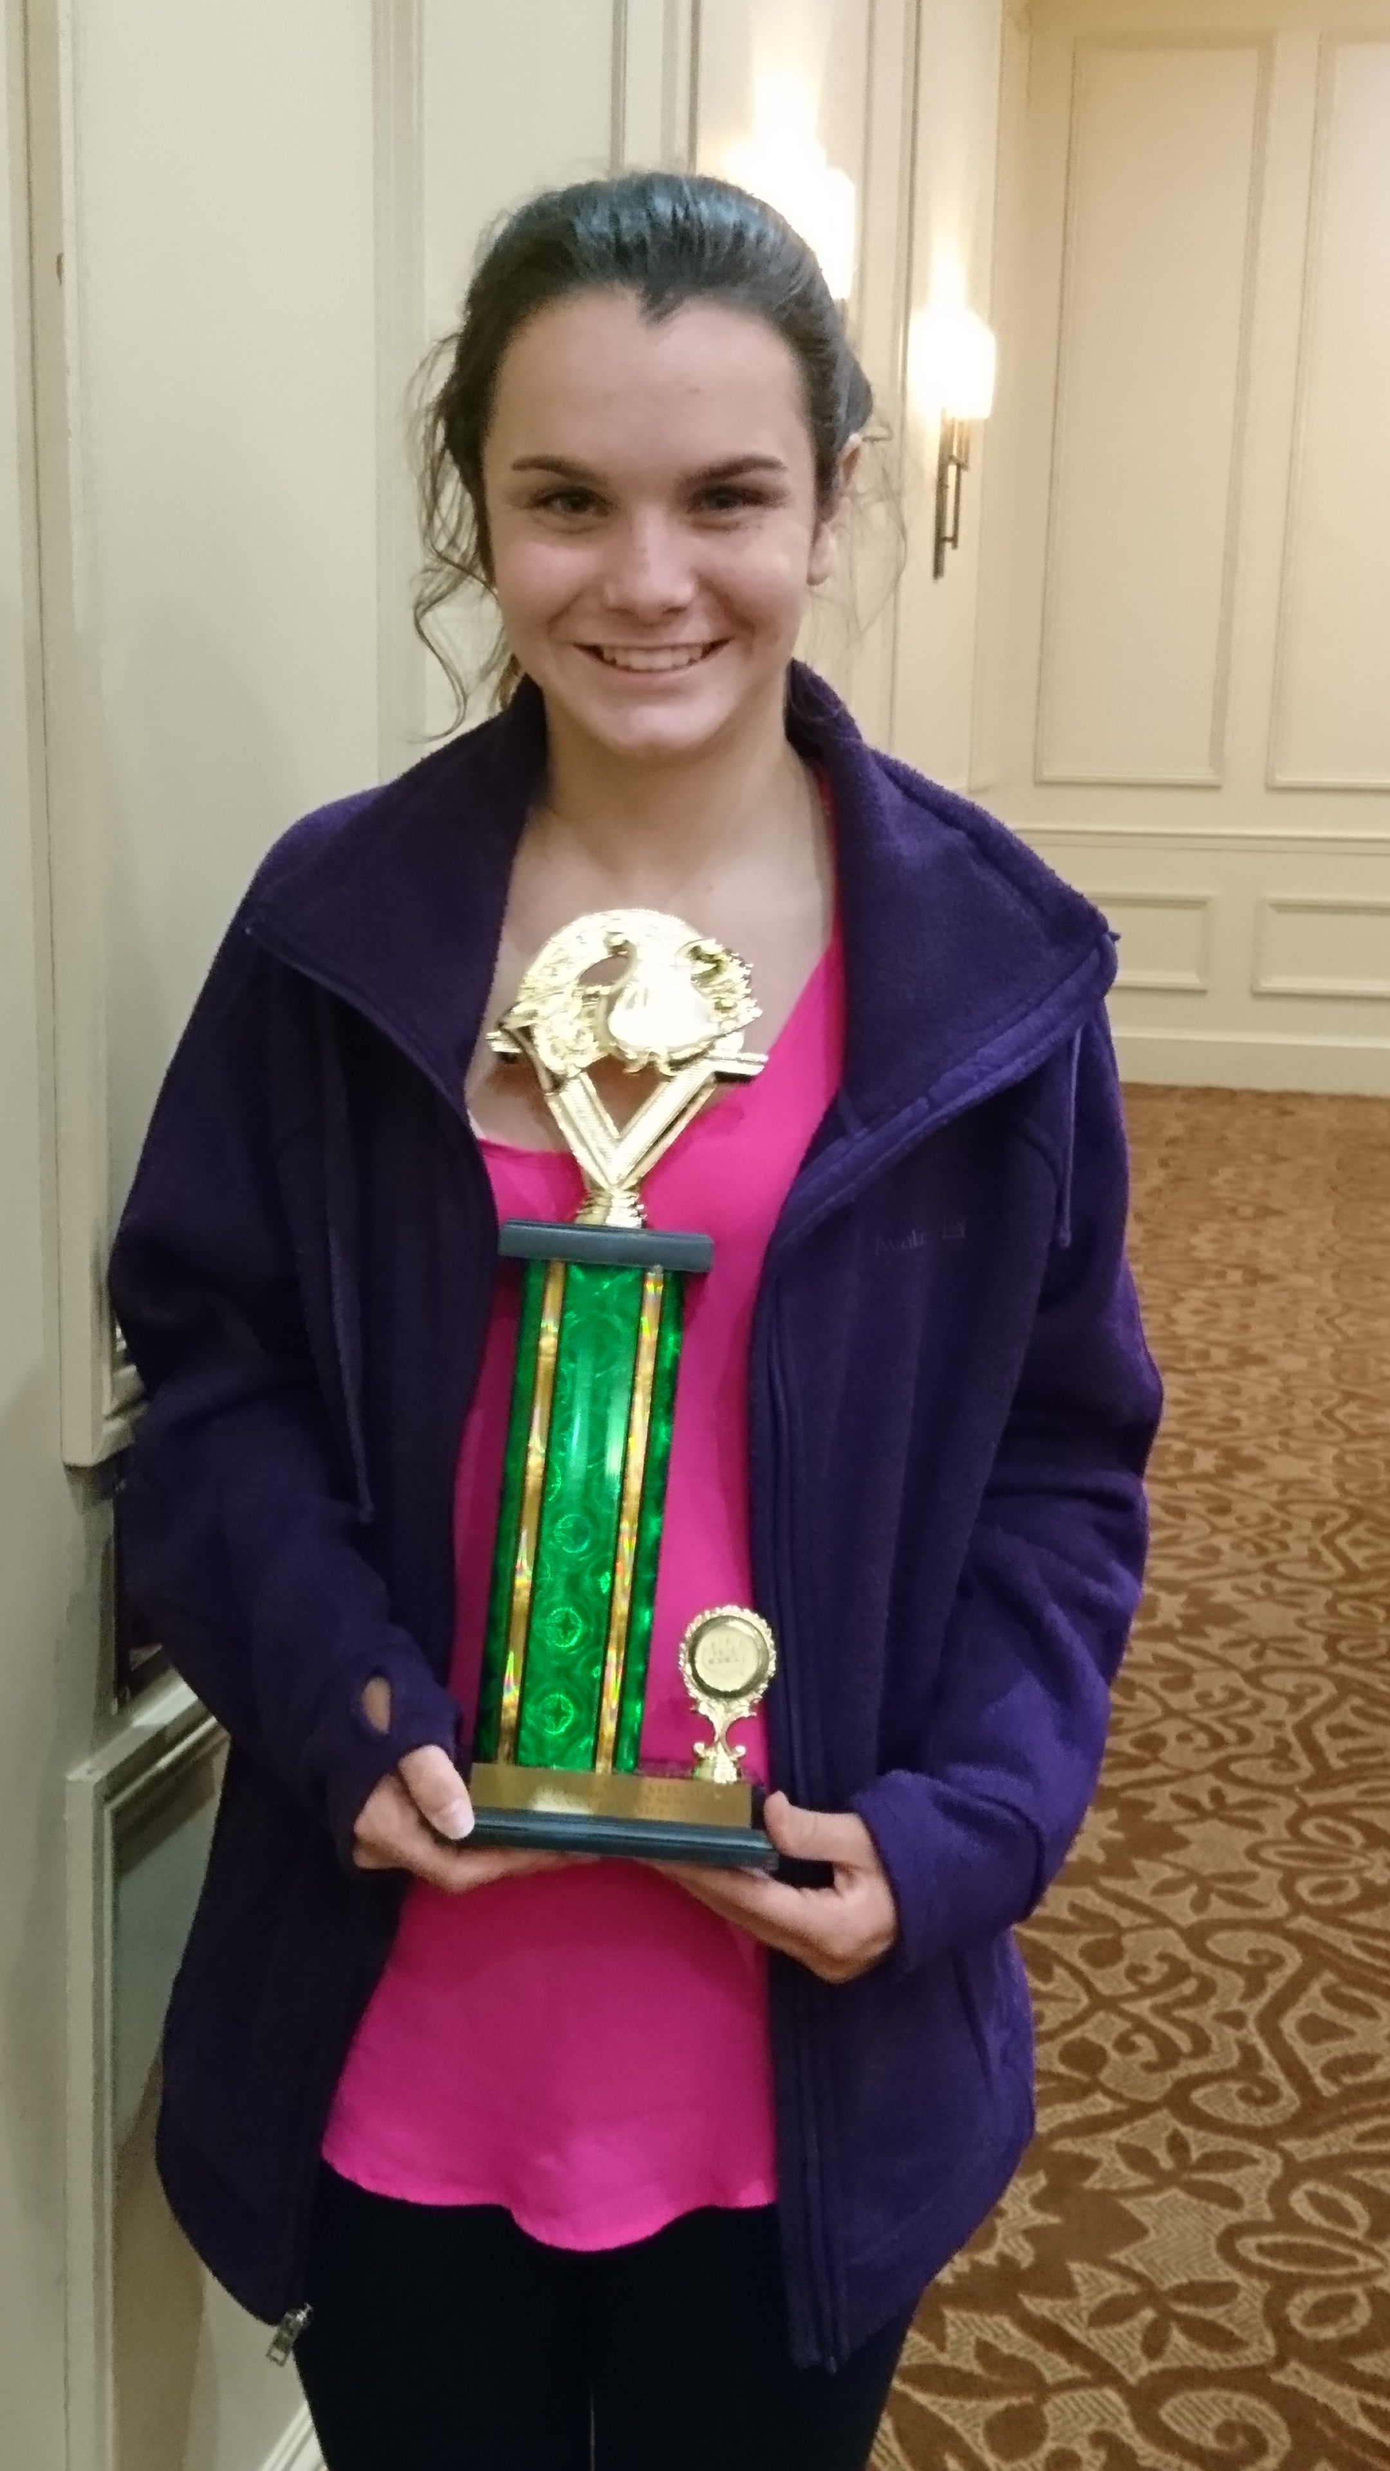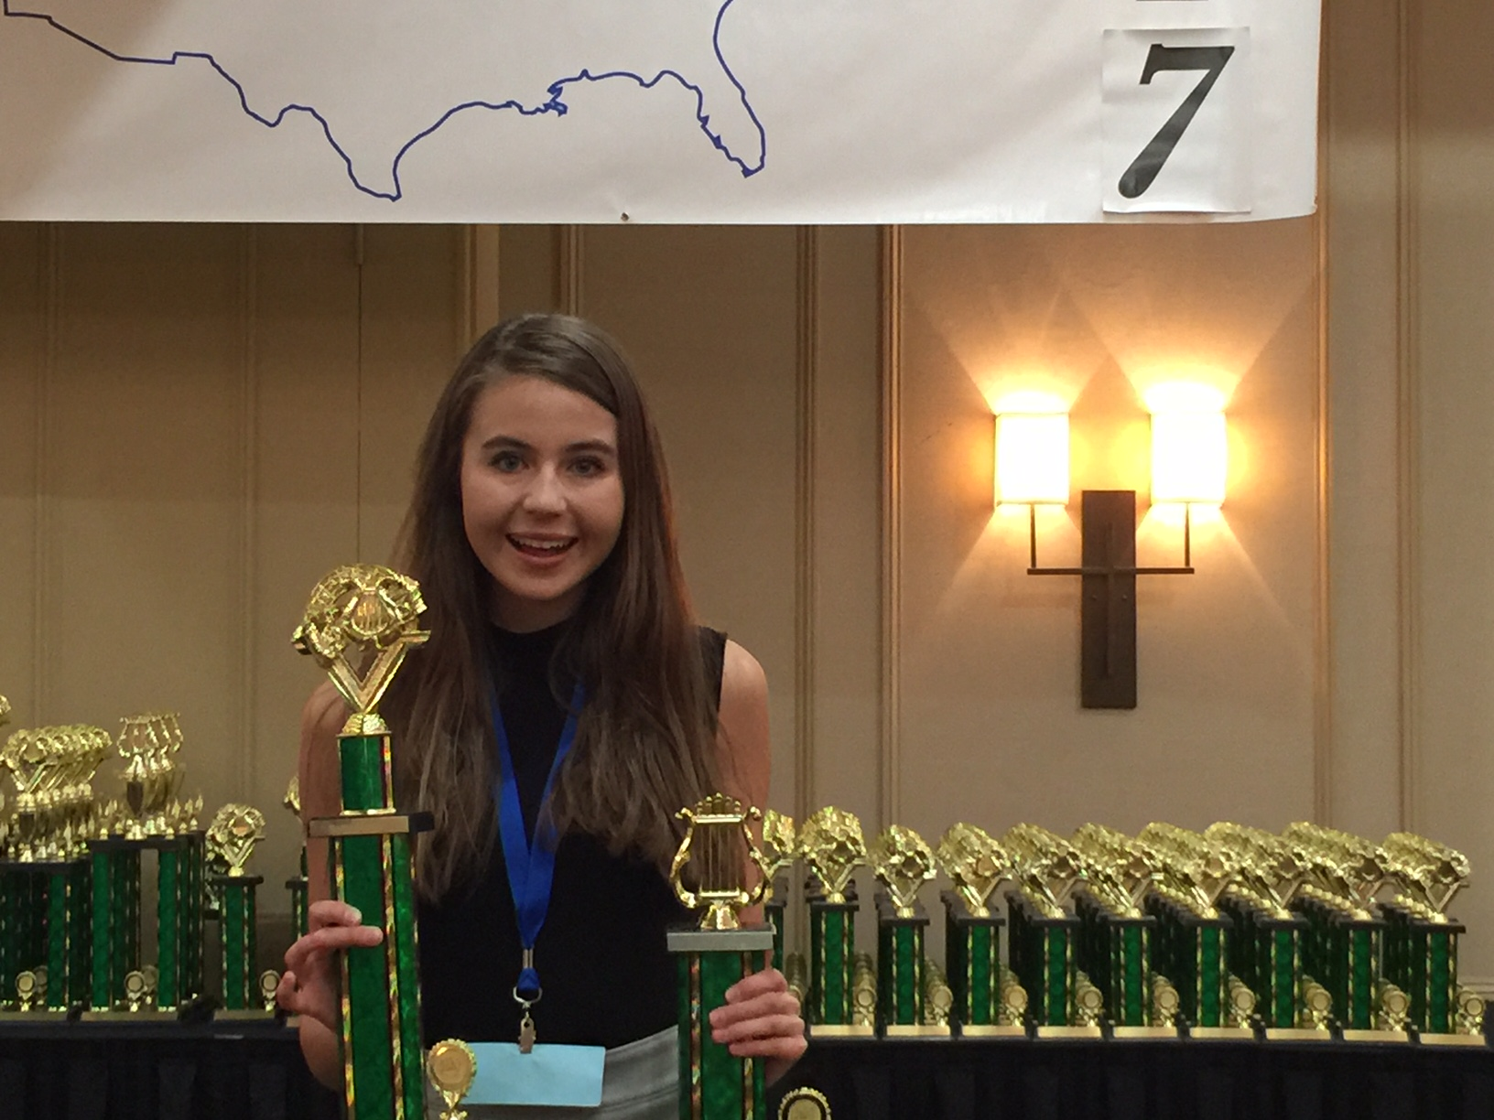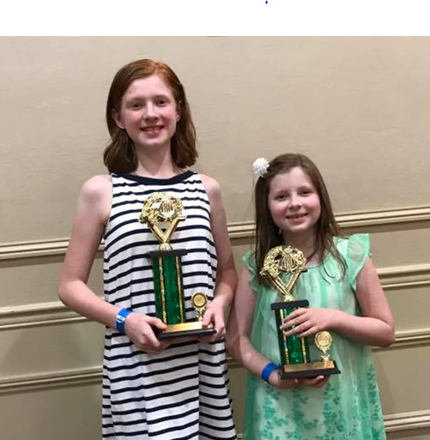
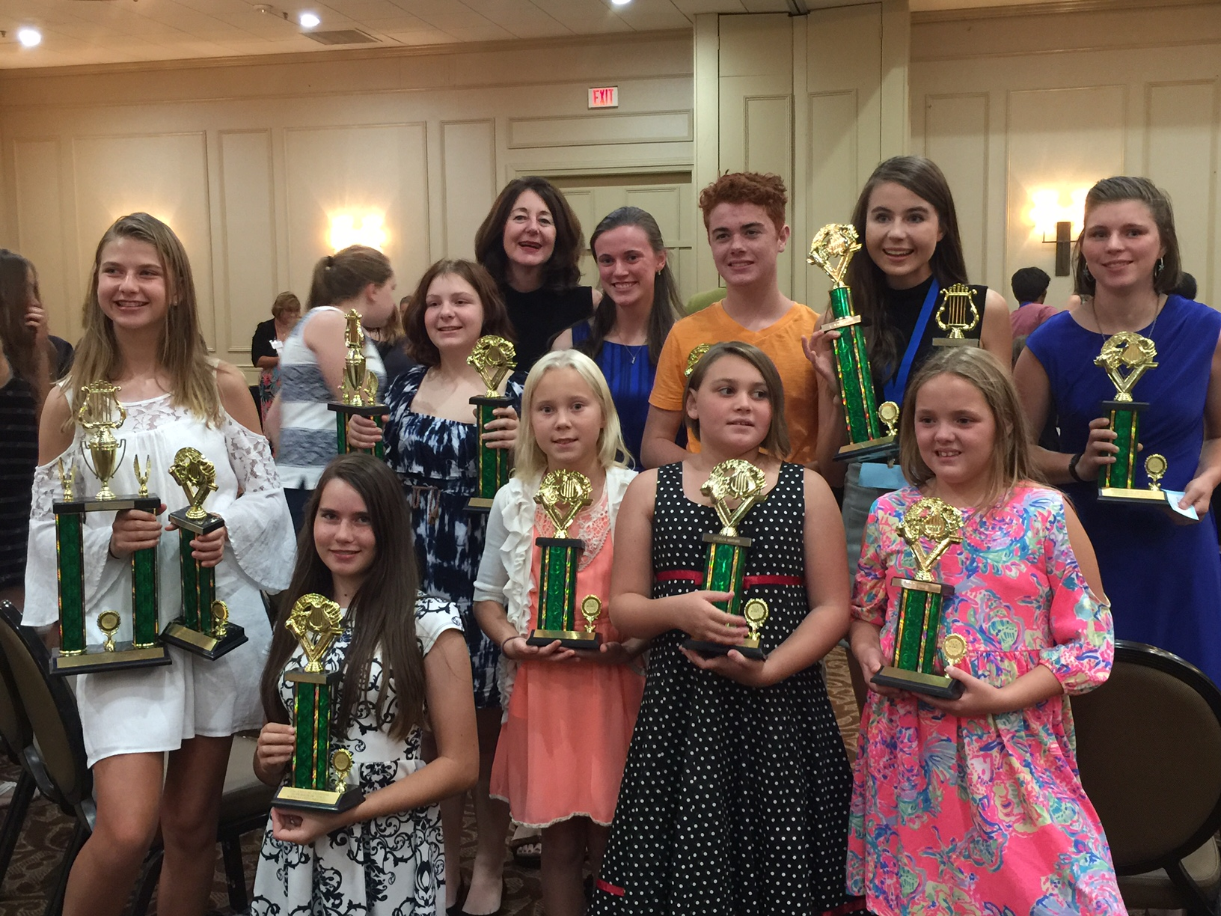
MAMA Students, L to R:

Regan McGonigle,
Lauren Cerbin
Sophia and Maura Tutt
The Cerbin MAMA Crew.

BONUS – 2017-18 BUDGET
The attached GAE Budget for 2016-17 will be discussed/approved at the August meeting. Here is the proposal:

Officers: President LeAnn Halvorson; Vice President Gill Cerbin; Secretary Tara Wright; Treasurer Karen Koch.
END

