GATEWAY ARCH EAST CHAPTER NEWSLETTER-November 2017
http://gatewaymusicteachers.org


UPCOMING EVENTS
Fri, Nov 17 GAE Meeting at Miller Music Store. 2017 ISMTA Conference Feedback sharing from attendees.
Sat, Dec 9 Clavinova Festival at The Beacon in Waterloo IL. LeAnn Halvorson has details. Entry deadline was Oct 28.
Wed, Jan 10 Midnight deadline for AIM Theory Registrations Levels 3-12.
Fri, Jan 19 GAE Schubertiad. 10 AM at Schmidt Art Gallery.
Sat/Sun, Feb 10-11 AIM Level 3-12 Theory Exams at SWIC

ISMTA CONFERENCE KNOWLEDGE ON TAP AT GAE MEETING NOV 17
GAE members who attended the November 3-4 state conference of ISMTA at Olivet University will share the best of their learning at the upcoming local meeting at Miller Music on Friday, November 17. Conference attendees included LeAnn Halvorson, Debbie Meier, Gill Cerbin, Amy Jo Sawyer, Catherine Burge, Joe Welch, and Karen Koch.
Several business items will also be on the agenda for discussion, including a proposal for a chapter-sponsored surplus music sale by members. Another business item will be upcoming vacancies for next year’s officers. According to the By-laws, an officer may serve no more than two consecutive terms in that office, and both the President and Treasurer are completing two consecutive terms.

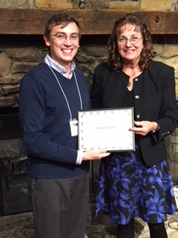
(L) At the Friday Conference Banquet, Joe Welch was presented with a certificate recognizing his selection as our Gateway Arch East Teacher of the Year for 2016-17. The presenter in the photo is Deborah Lynch, the ISMTA VP for Local Associations.

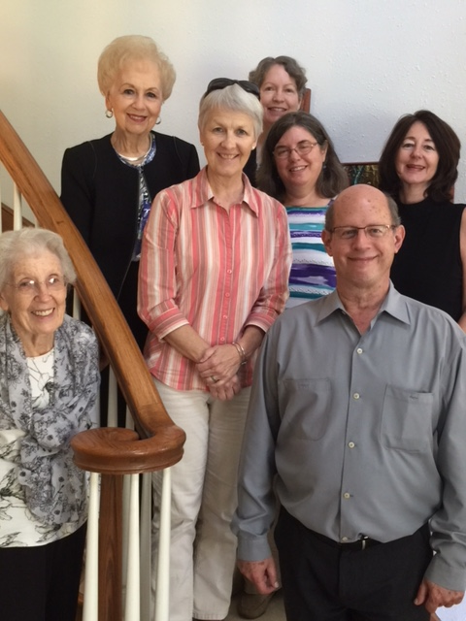

(R) Daniel Schene poses on the Cerbins’ stairway with some of his September audience members.

SCHENE SHINES ON IMPRESSIONISM
”Introducing Impressionism to Students” was Daniel Schene’s topic at the October 20 meeting, and he provided two hours of thoughtful pedagogical and historical knowledge punctuated by his glorious performances of Impressionist music ranging from “Fountains in the Rain” to compositions by Debussy and Ravel. His skillful pedaling technique was obvious, but he spoke also about the benefits of practice without the pedal, about developing the ability to voice a musical line within a single hand, and about selecting Impressionist literature for student skill development.
Enhancing the pleasure of this presentation was the ambiance offered by its location in the beautiful home of Gill Cerbin with both Boesendorfer and Steinway grands from which to choose. Gill provided seasonal refreshments from a stunning tea table setting, which resulted in bonus conversation with Mr. Schene in a social time. A huge thank you is due to Gill for arranging and hosting this exceptional program.

PIANISTS SPONSORED BY BELLEVILLE PHILHARMONIC
The Belleville Philharmonic initiative to bring world-class pianists to Belleville got off to a rocketing start Saturday, September 23rd. Pianist Alex Slobodyanik wowed the audience as he played Beethoven, Chopin, Schumann, and Prokofiev. There are 3 solo recitals remaining: Ian Gindes, January 13th, Elena Ulyanova, March 24th, and Lorraine Min, April 29th. All recitals are held at St. Paul United Church of Christ in Belleville, and would be enjoyed by teachers, students, and parents alike. Details can be found on the Philharmonic website www.bellevillephilharmonic.org

SCHOOL MUSIC TEACHER OPENING
St. Teresa Grade School in Belleville may still be seeking a part-time music teacher. Anyone interested should contact the principal, Mr. Birdsong, at 618-235-4066 or email him at skip.birdsong@stteresa.pvt.k12.il.us
(Ed. Note: This notice arrived shortly after the last newsletter went out, so it may no longer be current information.)
TIDBITS
GILL CERBIN’s daughter, Lauren, has been accepted into the Monsanto Artist-in-Training program operated by Opera St. Louis. She will be training with UMSL teacher Dr. Stella Markou and vocal coach DR. JOE WELCH. Gill’s students won 23 “Superior Plus” trophies at the St. Louis Arch Cup Competition held at Webster University and celebrated afterwards with an Arch Cupcake party. Gill’s voice students were finalists in the International Great Composer Competition Art of Vocal Performance in Music Theater. Student Catherine Mers took 2nd prize and Bella Crank and Hope Reeves were both awarded 3rd prize.
FRANCES GREGG has a new email. It is shown in the latest version of the 2017 online yearbook, but just in case you didn’t get the latest version, her new address is franceswgregg@gmail.com.
Our secretary, TARA WRIGHT, has added to her busy schedule at Swing City by accepting an opportunity to teach four classes for a homeschool program on Fridays. She is also working on creating her own company and continuing her farm duties while learning how to tune pianos! No wonder we don’t see much of her at meetings!
Health issues have been costly and difficult for both MARILYN BOYD and her husband during the past few months. He had successful hip replacement in June, while she has been dealing with a troublesome hiatal hernia and appendix. However they were able to celebrate their 50th anniversary with a return trip to Texas where they were married.
DR. STEPHANIE OWEN’S voice student Connor Johnson, winner of two idols, won third prize in Art Song and third prize in Musical Theatre in Great Composer international competition November 8.
DR. JOE WELCH has a couple of new jobs. He now coaches in Opera Theatre of St. Louis's Artists-in-Training program and is the accompanist for the St. Louis Symphony's Holiday Festival Chorus. He will also be principal keyboardist for the Illinois Symphony Orchestra's upcoming Holiday Pops concert, in which he will have a prominent role in their performance of Howard Blake's 1982 The Snowman movie score.
This item is actually a little more than a “tidbit”, but since it celebrates our own member, it is shown here. AMY JO SAWYER was commissioned by the Salt Creek Chapter of the Illinois State Music Teachers Association to compose music for their “Glorious Grands” Piano Concert presented Oct 8, 2017 on the campus of the College of DuPage, Glen Ellyn, Illinois, (near Chicago). The Commissioned Music was for Eight Hands (two pianos). The title of the Three Movement piece was “Sweet Salt Creek Suite”. The titles of the movements were: Cotton Candy Waltz, Rocky Road Blues and Toffee Tango. The selections were performed by sixteen piano students on eight “nine foot” Steinway pianos on one large stage. One of the piano instructors, Lemi Yang, from China, also played the accordion. The Salt Creek Chapter asked Amy Jo to include two accordion parts on the Tango, so she wrote parts for Lemi and herself to perform with the eight pianos. The concert featured thirteen groups of pieces by different composers with 245 students and 30 teachers participating. Two performances of the concert were presented to full audiences. This sounds like a spectacular event. Congrats, Amy Jo!

BONUS
Helpful research for piano teachers to know!
Excerpted from “How to Improve Brain Function and Reverse Poverty's Impact on Student Learning” by Eric Jensen. https://www.edsurge.com/news/2017-10-24-how-to-improve-brain-function-and-reverse-poverty-s-impact-on-student-learning

. . . .Cognitive skills are like apps that run the brain. For students who struggle, including children of poverty, telling them to pay attention or try harder isn’t going to accomplish much if their brains are not working effectively or efficiently.
Cognitive capacity is a core skill. It is the sum of our concurrent mental actions that learn, process, recall, calculate, reason and make decisions. Fortunately, cognitive skills can be taught, and the best place to start is with working memory.
Think of working memory like the brain’s workspace. It is a skill regulated by the brain that allows us to retain and manipulate information from different sources at the same time. Working memory is required for every higher order thinking process, no matter what the subject area.
Children who live in poverty are especially at risk because stress can limit working memory. In many schools, children with weak working memory are labeled as inattentive, restless or unmotivated, when they may simply be forgetting basic instructions or information before they begin the task at hand.
Teachers can be trained in brain-based learning to help students build and strengthen working memory. They can also implement simple strategies in the classroom, such as giving directions in multiple formats, organizing information into smaller chunks, making it multisensory or involving students in peer teaching.. . . . . Engage the Rules of Neuroplasticity Whether it is teachers or research-based software programs tasked with building students’ cognitive capacity, they must engage the rules of neuroplasticity:
- Students must buy into it. If the brain isn’t buying it, the brain isn’t changing.
- The skill must be coherent to the student, with increasing challenge and complexity.
- The best formats are game-like.
- Students’ brains need quality error-correction.
- Students need 30 to 50 minutes a day, three to five days a week for a minimum of three months.
- Once students get it right, they still need practice.
Indeed, personalized, intensive practice is what changes the brain and creates new connections—and it can happen fast. The impact of working memory training on gray matter can be seen in as little as five days. In a single school year, working memory training can yield gains equal to 1.5 to 2.5 years of progress.
* * *
(L) Hostess Gill Cerbin with President LeAnn Halvorson at the refreshment table for the October meeting.

END
Officers: President LeAnn Halvorson; Vice President Gill Cerbin; Secretary Tara Wright; Treasurer Karen Koch.

