
GATEWAY ARCH EAST CHAPTER NEWSLETTER

MAY 2017
http://gatewaymusicteachers.org
Illinois State Music Teachers AssociationPresident:LeAnn Halvorson; Vice President/Programs Gill Cerbin; Secretary: Tara Wright; Treasurer: Karen Koch
UPCOMING EVENTS

Fri, May 19 End of Year Luncheon at Hob House Southern Eatery, O’Fallon, 11 AM
June 10 & July 15 Summer of Play at the Schmidt Gallery, SWIC
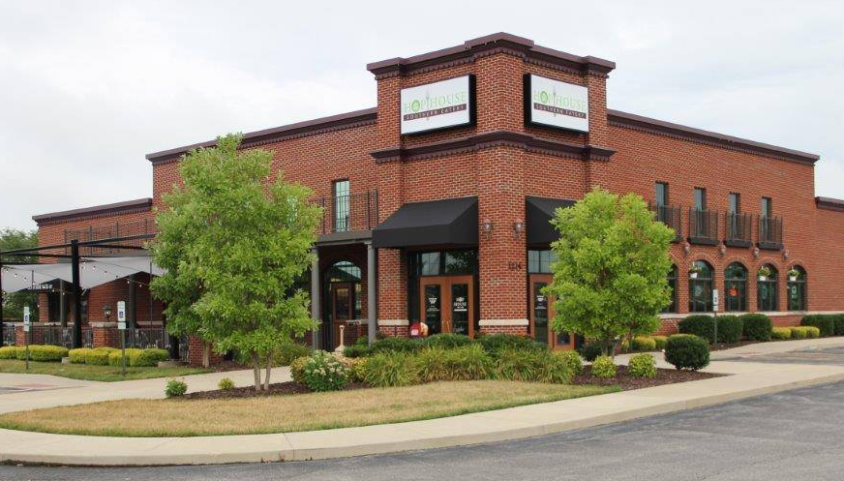
MAY MEET, GREET, EAT
Hob House Southern Eatery is the location for the final meeting of the year on Friday at 11 AM. This restaurant, formerly called Ravenelli's is at 1214 Central Park Drive, O’Fallon. FYI...the menu is available online. Look for the express menu on the last page; that food will be a reduced price during the time we will be there!
The meeting will be the time to review who’s doing what in our GAE chapter(officer election, Member of the Year, etc.) and get a sneak peak at programming for the upcoming year beginning in August—plus enjoying lunch with your favorite teacher friends!

SUMMER OF PLAY DAYS (formerly Day of Play)

Heidi Shepherd, 618-632-4192 is accepting signups for this year’s “Summer Play at the Schmidt”. GAE teachers this year have two opportunities to showcase their students. The Schmidt Art Center Director has graciously offered Saturday, June 10 and Saturday, July 15 for students to perform. Both days the program begins at 2. Contact Heidi for info.

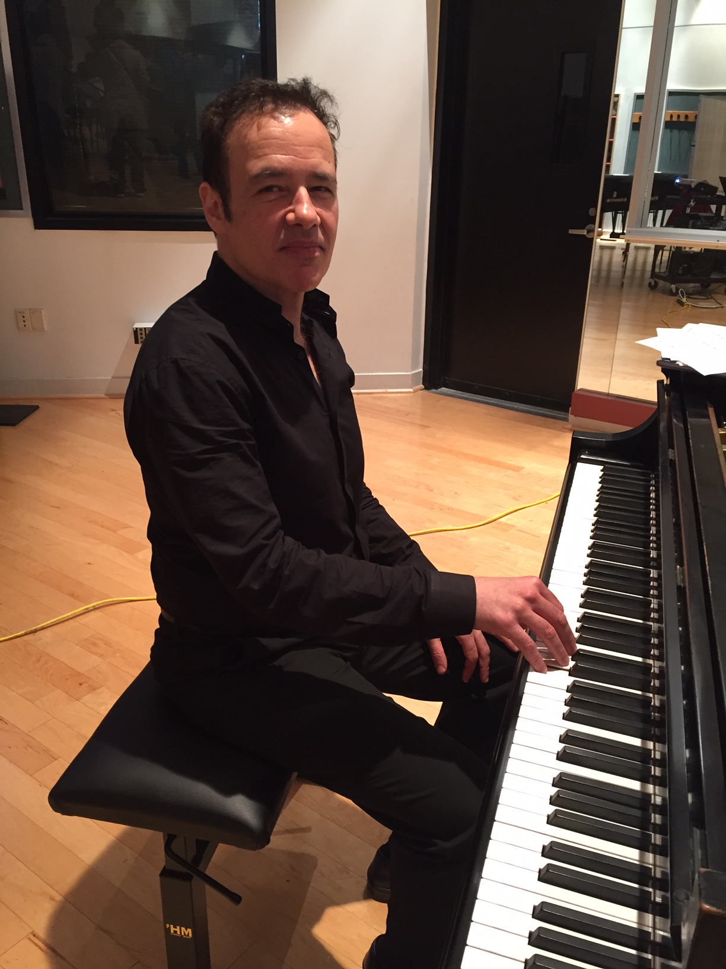
DR. TSITSAROS BROUGHT AN APRIL SHOWER OF INFORMATION

A large gathering of students and community members joined GAE members to hear Dr. ChristosTsitsaros on April 21 at SIUE, and they were treated to an interesting, educational, and useful morning. Professor and Chairman of the Piano Pedagogy division at the University of Illinois at Urbana-Champaign, Dr. Tsitsaros shared his approach to using natural freedom of movement in order to achieve greater artistic results. He demonstrated simple exercises based on his study of Chopin’s technique and his own experiences with students to relieve tension, to use the body comfortably and to practice for artistic results. He also performed some of his own compositions, to great effect and appreciation. Prof. Tsitsaros gave GAE a CD of his easier works, with him playing them. Gill Cerbin has the CD if anyone would like to borrow it.

SWIC AIM PERFORMANCE EXAM REPORT (from Joan Witte)

Thanks to all who participated in this year's AIM exams. We had thirteen teachers participating in performance exams at SWIC with a total of 92 students registered.
Congratulations to the following students who completed level 9 or above: level 9 – Wren Heiligenstein, student of Karen Koch; Christine Fink, student of Gill Cerbin; Breanna Goyea, student of Amy Jo Sawyer; level 11 – Grace Reuter and Andrew Romano, students of LeAnn Halvorson; Jordan Nguyen, student of Amy Jo Sawyer. Sienna Stroud, student of Amy Jo Sawyer, completed the level 12 theory exam and will be completing the performance exam this summer. These students and teachers are to be commended for their hard work!
In addition to plaques/bars and certificates, those students mentioned above who received a passing score on both theory and performance will also be awarded cash prizes from GAE in the following amounts: $25 for level 9, $50 for level 10, $75 for level 11, and $100 for level 12.
Ed./Treasurer’s Note: student checks have been mailed to the teachers.

TIME TO RE-UP!
So far, GAE has twelve members who have paid dues for 2017-18. If you are not one of them, now is a good time! Some members will renew automatically, because
they understand the value that they receive for their membership and how
MTNA meets their needs. Others will renew based on emotion, because of
shining moments they have experienced...a student event where new heights
were achieved, or a compelling performance by a guest artist or for the opportunity to participate in AIM or contests. One highlight for those who attend is always the ISMTA Conference weekend. The 1917-18 event will be November 3-5, 2017, at Olivet Nazarene University in Bourbonnais, IL. It will showcase Panayis Lyras, professor of piano and artist in residence at the Michigan State University College of Music, as the ISMTA Conference Artist, along with many presentations to inspire teachers.

TIDBITS
LE ANN HALVORSON’S former student, Tad Arndt is now a freshman at the University of Illinois. He was recently featured in an article in the Daily Illini student newspaper, with the headline “Piano Man Uses Musical Talent to Bring People Together”. You can enjoy it here.
If you are interested in a church organist position for “spirited traditional worship”, you can contact LE ANN HALVORSON’S pastor, Ann Mowery, at pastorann@stlukesumcmo.org 314/892-5595 for more information.
One of DEBBIE MEIER’s former students has a Wurlitzer piano for sale in excellent condition. It was built in 1995 and was purchased from the Steinway piano store in St. Louis. The store is suggesting a current value of $1,800. Contact Deb for contact information.
DR. STEPHANIE OWEN has the following information to share. Vocal student, Frankie McClary was chosen as supporting lead in Little Mermaid put on by St Teresa School in Belleville. She played the role of Sebastian. NBC The Voice on television has chosen one of Dr.Owen's students for level 1 auditions this season. The Voice will make the announcement. Olivia Gregory student has accepted a free ride in opera at Kansas city College Conservatory for 4 years.

BONUS

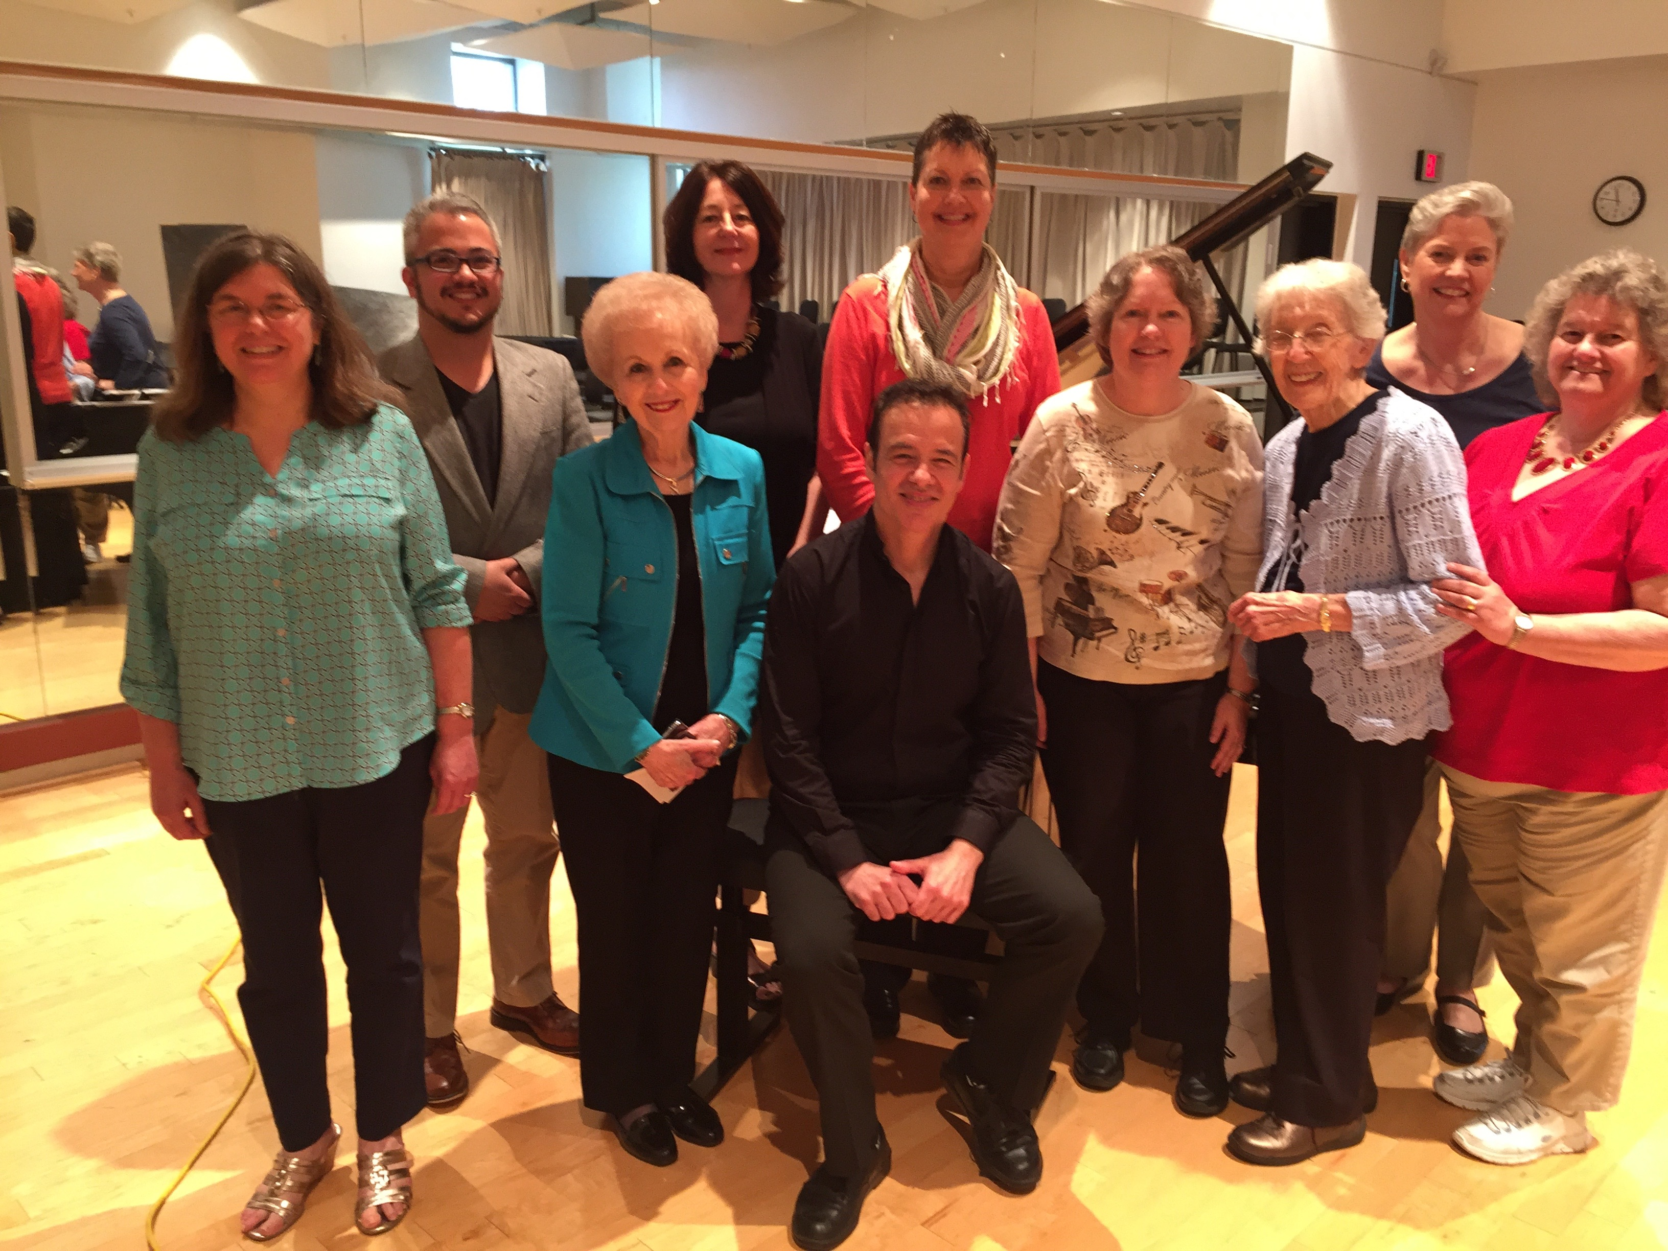
Some GAE Members with Dr. Christos Tsitsaros following the April 21 GAE meeting.

Become a Music Student Exchange Host or Partipant
The following message has been forwarded by Heidi Shepherd, and may open a whole new opportunity for someone!
Heidi, I found your contact information on the MTNA website. NorthWest student exchange would like to pair up with your chapter in spreading the word about cultural exchange. If you know of a family that has a teen or a family involved in music please let us know. We are working on finding a host for our music focused students and it would be great if they had a family with the same interest. NWSE does offer a175.00 referral incentive to your Chapter if a family or individual referred does host with us.

Luca is a confident and well-rounded 16-year-old boy from Germany. He describes himself as friendly, open-minded, tidy, polite, and humorous. He is involved in a number of different activities. He plays on the school soccer and volleyball teams, as well as the community table tennis team, which he does with his brother. He has also been playing the violin for eight years and is a member of the youth symphony orchestra in the neighboring town. Because of his strengths as an organizer, he also serves in various leadership capacities. For example, he works as a private tutor for younger students, and he was elected to the student government, where he is responsible for organizing different student events.

Yanchen, whose nickname is David, is a 16-year-old boy from China. David plays saxophone and basketball. He also loves trying new food. In his spare time, he likes to listen to music. If possible, David would like to continue playing saxophone and basketball and try math club or band during his exchange in the US.

Ruben from Germany is 16 years old. He has been playing piano since he was six. Among his other hobbies are MMA and he use to play soccer and field hockey.

Hiroka is a 17-year-old girl from Japan who plays piano and trumpet. In her spare time, she likes to read comic books and novels. She also plays badminton, but because she has a long commute to her senior high school, she hasn’t been able to join clubs or sports. On her exchange, she would like to play the trumpet, play badminton, and learn a third language, if possible. Hiroka likes to cook and hopes to learn some American recipes on her exchange

Yiwen is a 15-year-old girl from China who will turn 16 before her exchange. She is her class supervisor and the president of the school “Kindness Society.” Yiwen plays the piano and enjoys drawing, painting, sewing, and knitting. At school, Yiwen volunteered to play piano at a retirement home and was very moved by the experiences of the people there. She also likes cooking, drama club, and playing sports. Yiwen’s favorite hobby is photography.

Kamila is a friendly, responsible, and thoughtful girl from Kazakhstan who turns 15 at the end of March. Her favorite hobby is playing the piano, and she has been taking piano classes for five years. When she’s not practicing music, Kamila likes to cook, knit, watch movies, and read books, specifically classic Russian literature

​Marge Ryan, Regional Manager NWSE​ email marge@nwsemail.org​
Phone 262 749 0564 Fax 800 613 5105
Skype Marge.Ryan www.nwse.com
NWSE Video https://www.youtube.com/channel/UCGYFzKbKeQnZ_42V0lYauYw
NWSE is a Department of State-designated nonprofit organization listed with CSIET
www.facebook.com/go.nwse

More information on the sponsoring organization, Established in 1987, NorthWest Student Exchange is a non-profit, international high school exchange organization, designated by the U.S. Department of State and listed with the Council on Standards for International Exchange and Travel (CSIET).
NorthWest Student Exchange offers a variety of international exchange opportunities for both international and American youth: academic-year, reciprocal, semester, and summer programs. Students enjoy living with their host families, attending high school, while receiving supervision from local NWSE Academic Coordinators. They also participate in community or NWSE-sponsored cultural and social events. NWSE provides student and host family orientations, and coordinates medical and accident insurance, travel, and visas for all exchange participants. NWSE screens and selects all participating students and their host families. Our screening and matching process works! Over the years, NWSE has maintained a high Student Placement Success Rate. Only rarely do our students have to be relocated to a family other than the originally NWSE-screened family. Dedicated to personal attention for every participant, NWSE promotes cultural exchange, foreign language study and international education by creating affordable opportunities for high school students to participate in international exchanges. These unique opportunities for personal development, new perspectives and insights, and foreign language competency help prepare students for success in the global marketplace and improve international understanding. NWSE program participants raise their global awareness by building long-lasting international friendships and memories.

NWSE representatives across the United States work with schools and hosts to ensure each exchange experience is monitored and managed for optimal success. Our representatives, called Academic Coordinators, are conscientious and dedicated individuals. NWSE closely screens and extensively trains all Academic Coordinators who work with us.

END

