GATEWAY ARCH EAST CHAPTER NEWSLETTER
August 2016
http://gatewaymusicteachers.org Illinois State Music Teachers Association
President: LeAnn Halvorson; Vice President/Programs Gill Cerbin; Secretary: Tara Wright; Treasurer: Karen Koch
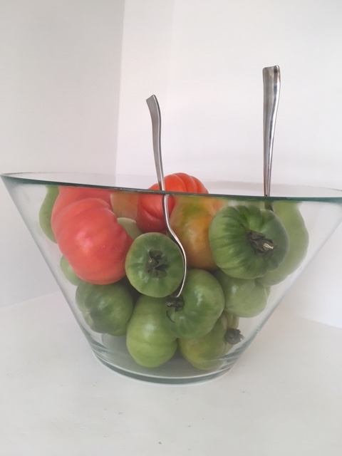Tomato Quarter Notes!
2016-17 UPCOMING EVENTS
Fri, August 19 GAE Opening Meeting 10 AM at Swing City, 1811 Vandalia, Collinsville. Susan Lipnick on MTNA Certification.
Wed, September 14 Entry deadline for the 2016–2017 MTNA Student Competition for ages 11-26 in performance and composition. Info below.
Fri, September 16 GAE Meeting 10 AM at Swing City, 1811 Collinsville. Eric Sutz on Myofacial Release of the Body.
Fri, October 21 GAE Meeting 10 AM 10 AM at 10 AM, McKendree University Hettenhausen Center for the Arts. Presenter
Dr. Joseph Welch.
GAE Opening 16-17 Meeting in Collinsville
Our newly elected GAE Secretary, Tara Wright, has offered a wonderful new venue for some meetings this year at Swing City in Collinsville where she is employed. They have excellent technology facilities and support for some planned online presentations by distant presenters this year. The inaugural one will be Friday, August 19 when former GAE member Susan Lipnick will do a Skype presentation with Q & A on how to become nationally certified by MTNA. If you have ever considered this, here is a chance to become informed and inspired.
Looking ahead, the September meeting will also be at Swing City. According to Program Chairman Gill Cerbin, this will be virtual, but hands-on, by Eric Sutz of Chicago to help us with flexibility and pain. For his presentation, “Myofascia Release for Your Arms and Shoulder”, We are asked to bring baseballs, yoga tune-up balls, or la cross balls if available to that meeting!

3RD FRIDAY GAE Meetings for your Calendar
Aug 19, Sept 16 , Oct 21,Nov 18, No meeting December, Jan 19,
No meeting February, Mar 17, Apr 21. A personal call to invite a non-member to a meeting will make a difference for them and for our chapter! Do it.

ANY CHANGES? TIME TO UPDATE YOUR INFORMATION
Joan Witte is in the process of putting together the 2016-17 GAE Yearbook. If any of your personal information or list of teaching areas has changed from last year’s yearbook, please send the changes to Joan at joan.witte@sbcglobal.net, or call (618) 228-7202. If you would prefer that any of your personal information (address, phone, or email) not be published on our website, please send your preferences for that as well, and a note will be included when the yearbook is sent to Lauren Halvorson, our website coordinator.

CLAVIER COMPANION GROUP SUBSCRIPTIONS
If anyone would like to receive Clavier Companion, please contact Debbie Meier. The group rate for a one-year (6 issues) print subscription is $20 as long as we have at least 5 people sign up. If interested, please send Deb your current address. The magazine will be sent to the address you provide.
SUMMER WORKSHOP
Thursday, Aug 18, 9 am to 12:30 pm, Alfred Music Publishing Piano Clinic, featuring. Tom Gerou at Midwest Sheet Music, 2616 Metro Blvd, Maryland Heights, MO 63043. Register at music@midwestsheetmusic.com

MTNA STUDENT COMPETITIONS
The entry deadline for the annual national competitions is Wednesday , September 14, 3:00 P.M. EASTERN time. Online applications will be available in August.
Competition levels:
Junior: ages 11–14 (Piano, String, Woodwind) Senior: ages 15–18 (Brass, Piano, Piano Duet, String, Voice, Woodwind) Young Artist: ages 19–26 (Brass, Piano, String, Voice, Woodwind) Chamber Music: average age 18–26 (String and Wind)
Composition:
Elementary: ages 5–10 Junior: ages 11–14 Senior: ages 15–18 Young Artist: ages 19–26 Find Competition Guidelines here. For further information, contact:Linda Stump, NCTM MTNA Director of Competitions lindastump@mtna.org

RUBY TUESDAY WAS A RED LETTER FRIDAY FOR ATTENDANCE
The GAE final meeting/luncheon on May 20 at Ruby Tuesday drew attendance of 14 members and one guest. New officers were elected, including Gill Cerbin as Vice President/Program Chair and our newest member, Tara Wright, who jumped in immediately by accepting the office of Secretary. President LeAnn Halvorson and Treasurer Karen Koch will continue in their offices for a second term.
Amy Jo Sawyer was selected as the Gateway Arch East nominee for ISMTA Member of the Year. This is a new award being instituted by the state organization for the coming year, and is separate from our local Member of the Year selection.
This year’s AIM report was discussed and the teachers of students who have completed AIM Levels 9-12 received their students’ GAE Award Checks. To facilitate exam scheduling for next year, members approved Joan Witte’s recommendation that exams be condensed into fewer days for 2017. Details will be covered on the updated forms available online.
Construction of the new GAE website by Lauren Halvorson came in only a few dollars above the budgeted amount. LeAnn requested that any updates for the website that are needed be sent directly to Lauren at mailto:fishmas2@gmail.com rather than to LeAnn. (Mother and daughter no longer share a physical address!) The GAE Directory will be updated by Joan Witte and posted by Lauren on the website for the upcoming year.
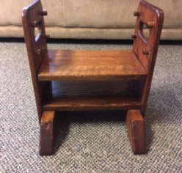
ADJUSTABLE FOOTSTOOL AVAILABLE
FOR SALE: Adjustable footstool for younger students. Great condition, solid wood as hand crafted by a parent years ago. $15. Delivery at the August 19 meeting if desired. Contact Karen Koch, 224-7102 kk@musicedmarket.com.

INCENTIVE FOR NEW MUSIC LINK STUDENT REGISTRATION
Illinois State MusicLink Coordinator, Deb Meier, invites you to consider becoming a MusicLink teacher. If you are already giving lessons to a student at a reduced rate of 50% or more, you can easily sign up. For more information, go to www.musiclinkfoundation or talk to Deb. She will help you get started. The MusicLink Foundation would like to reward any teacher who registers a new MusicLink student between August 15th and October 1st. Carol Matz has very generously offered a special PDF download of one of her pieces PLUS a free book to any MusicLink teacher who registers a new student between those dates--this means new MusicLink teachers AND existing active MusicLink teachers. If you are an active MusicLink teacher (currently teaching a MusicLink student), you must sign in from the Home Page. If you are inactive, you can reactivate by contacting Sue Wege,swege71@comcast.net
http://www.musiclinkfoundation.org

TIDBITS
Lookinglass Players of Lebanon featured a number of GAE teachers’ students in the June performance of “AIDA”. LeANN HALVORSON’S student Grace was the main piano accompanist for “AIDA” production.
Among DR. STEPHANIE OWEN’S voice students, Liam Brenzel won the supporting lead of Zoser and Kira Averett won a lead in “Fiddler on the Roof “. Stephanie’s voice student Lauren Cerbin won first place in an international competition “Great Composers” in three categories: opera, musical theatre, and sacred. Competitors also came from United Kingdom, Australia, and Canada. .Vocal student of Liam Brenzel won was in “Mamma Mia” July 2016 at the Muny and won the lead of Zoser in “Aida” at Looking Glass June. Vocal student Kira Averett won the lead of Ariel in “Little Mermaid” at Family Theatre of St.Louis in July. Vocal student Stef Rickhoff won call backs for the part of Narrator in “Joseph and the Multi Technicolor Dream” at Looking Glass, August 2016. Piano student Dr Jennifer Hund has been selected as pianist for “Rocky Horror Show” and “Joseph and the Multi Technicolor Dream” at Looking Glass for August 2016. Obviously, Stephanie didn’t take the summer off from teaching!
DR. CATHERINE BURGE has accepted a position as music professor at Briercrest College and Seminary in Canada beginning August 15. She is excited and we are happy for her, but this is a big loss for GAE. This now makes her an international member of MTNA.
LEANN HALVORSON and DEBBIE MEIER attended the 8-day session of KETS15 in Edmond, OK in June, led by Susan Ogilvy. They report that it was another great experience. Both are becoming more proficient at using the great technology that the Clavinova has to offer and they look forward to another upcoming Yamaha Clavinova Festival in the near future.
“Fiddler on the Roof” at the Muny enjoyed the services of AMY JO SAWYER in the on- stage orchestra performing 104 pages of keyboard and accordion music during the week of July 31-August 5. Lots of practice involved for her! Amy Jo also stays busy as President of the Accordionists & Teachers Guild, and July 19-23 was involved with attendees at their Chicago convention from China, New Zealand, Canada, and the US. A quintet of accordionists performed two of her original pieces at one concert.
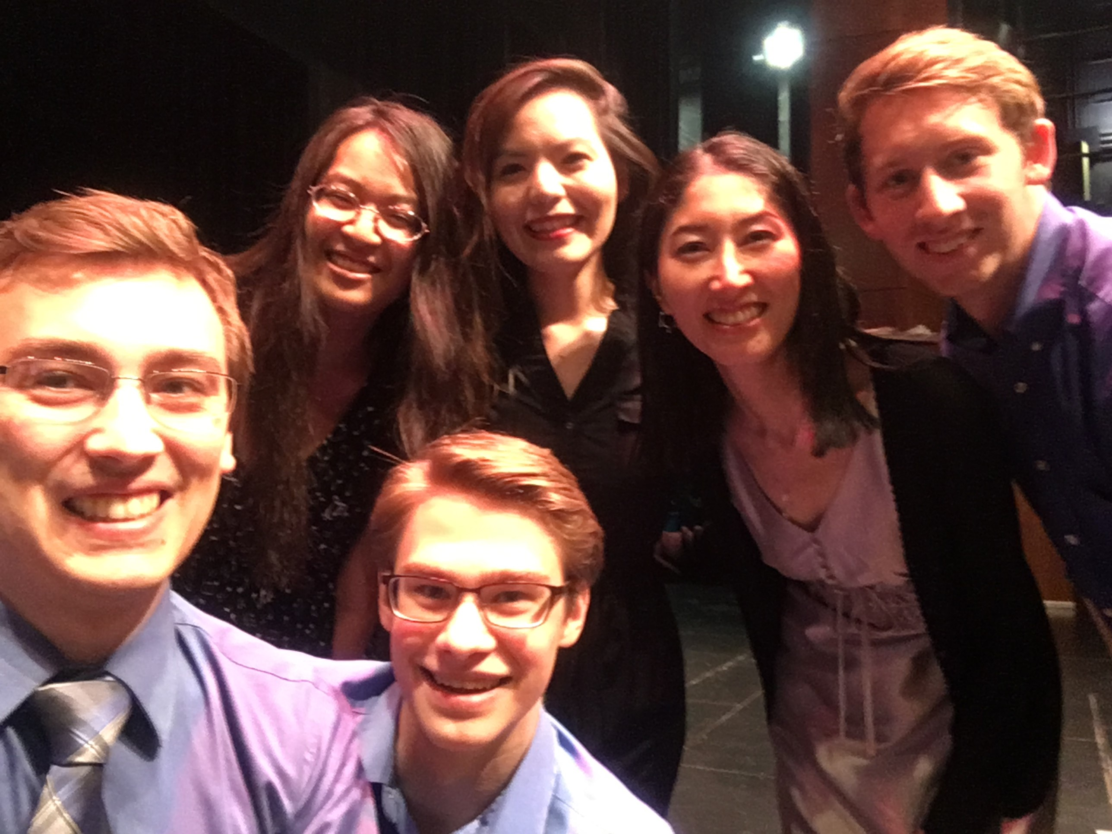
DR. JOSEPH WELCH at McKendree University organized “The Business of Being a Pianist” for a second year in June. The three-day workshop featured KAREN KOCH, Dr. Jen Gartley, and Cheryl Marting presenting about their careers as teacher/business owner, non-profit administrator, and piano technician. Dr. Nancy Ypma gave demonstrations on harpsichord and organ playing as well as talked about her career teaching in higher education. Nancy Mayo and Vera Parkin coached master classes in which the students accompanied McKendree alumna Grace Fisher. The students also learned about branding and marketing and had their headshots taken by Abi Warix.
Mid America Music Association (MAMA) this summer had three GAE participating teachers. Their six students ALL received Superior ratings. Teachers were LEANN HALVORSON, DEBBIE MEIER, AND GILL CERBIN. Of particular note was the LeAnn’s student, Andrew Romano (AIM Level 10 in 2016), who got a perfect score on his concerto, the 2nd movement of the Grieg A Minor Concerto. Former member Pam Masching’s students won Division II of the Theory Bowl as well.
KAREN KOCH has spent a good part of the summer reorganizing her business by merging her warehouse and website with that of Michelle Sisler’s Keys To Imagination.com in Owatonna MN. Karen will bring some Closeout items to the GAE meeting, after which she will no longer be filling orders from her home. Remaining duties include marketing, conferences, and blogging for the merged businesses.
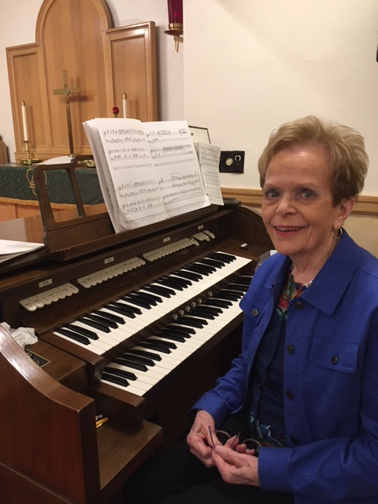
BARBARA KRAMER was honored on July 10 for her 40 years of service as Music Director of Bunker Hill First Congregational Church and her 80th birthday. The surprise was successful as engineered by her daughter Rachel Kramer, also a piano teacher and former staff member of MTNA in Cincinnati. During the morning service, Barbara’s church choir surprised her by performing a beautiful piece that had been commissioned and dedicated to her, and conducted by the composer. She received proclamations from the mayor, a state representative, the Illinois legislature, and many family and friends in attendance. A sumptuous luncheon followed in the beautifully decorated church hall to climax a well-deserved observance of her many years of leading and supporting beautiful music for her community.

BONUS
Here is some food for thought in this Olympic summer when amazing “talent” is on display.
“ Practice Makes Possible”http://www.npr.org/sections/ed/2016/06/01/479335421/practice-makes-possible-what-we-learn-by-studying-amazing-kids . An NPR program based on the book PEAK: Secrets from the New Science of Expertise by Anders Ericsson and Robert Pool. END

